Dear

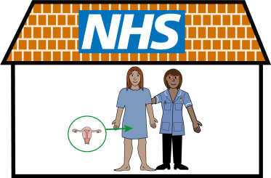 | It is time to book your cervical screening test. This is sometimes called a smear.
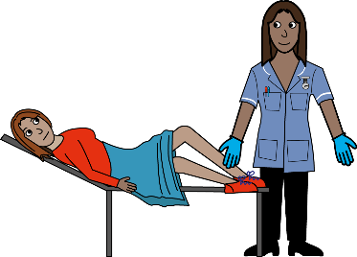 | This test that looks for HPV (a virus) in your cervix. HPV can develop into cancer if you don’t get it treated.
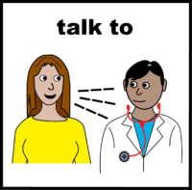 | You can talk to the person doing the test and ask any questions you have. They will help you and talk you through the test.
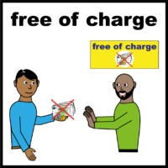 | This is a normal routine test. It is free and helps save thousands of lives every year in the UK.
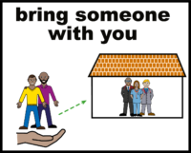   | You can bring a friend or carer with you to stay with you throughout the test. Your results will be sent to your home.
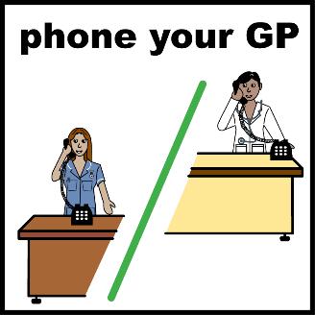 | Please contact your GP practice to book in for a time that suits you and tell us about your reasonable adjustments.
 | For more information please go to:  https://www.gov.uk/government/publications/cervical-screening-easy-read-guide
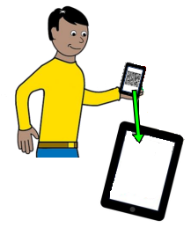   | To listen to this letter please scan this QR code with your phone camera. You can also see the letter in another language.  (QR code)  
 | Or you can follow this link to listen to the letter or see it in a different language.  https://www.healthandcareleeds.org/cervical-screening/

With thanks to  

