Primary Care Public Involvement group
Friday 5 May 2023 – 1:30 – 3pm at The Old Fire Station

Attended: Lilla Tan (Leeds Involving People), Martin Schweiger, Janet Stowe, Margaret Wilkinson, Graham Burns, Anne Heeson, Adam Stewart (Integrated Care Board in Leeds), Graham Fox, Pat Newdal, Elizabeth Letaief, Emma Greetham, Debra Backhouse (ICB in Leeds), Chris Bridle (ICB in Leeds).

Apologies: Maggie Dawkins

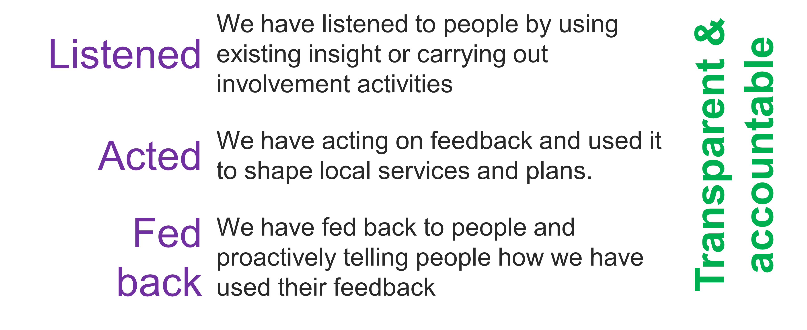
Introductions
The group introduced themselves and CB outlined the purpose of the group. This group has been developed to support the board to involve local people in its decision making. Success would mean that the board have listened, acted and fed back. CB explained that this approach is being trialled and the role may look different in the future.

Role of the group
The group discussed how the group would work. We agreed that the group should constantly remind itself that its membership does not represent diverse communities and that we need to use feedback from the wider community to inform our work. This might include:
- Involving third sector representatives who understand the needs and preferences of ‘underserved’ communities.
- Being aware of communities that make up the population of Leeds
- Focus any future involvement on gaps in our understanding and accessing communities that are underserved.
- Focus on what we already know about what people need by using the primary care insight report
- Spend more time on ‘making a difference’ in areas such as the Accessible Information Standard

The group discussed that it was easy to get taken off track and discuss things that were outside our remit and influence. Agreed that it would be helpful to focus on one or two issues where we can make a difference (quick wins).

It was felt that guidance from the board as to how they want us to support them would be useful.

The group was reminded that primary care covers more than just GP practices and that we need to consider needs around things like pharmacy and especially dentistry.
Challenges facing primary care
The group agreed that the themes identified in the insight report reflected the key primary care issues facing people in Leeds. They also identified a number of other issues that they felt were areas of concern:
- Communication/information – do people understand the role of primary care, how it is changing and how to access it effectively?
- Timely care – can people access ‘fit notes’ quickly enough so that they can return to work.
- Involvement in service development – There was a great deal of discussion about the benefits of PPGs as a way to involve local people. Many participants felt that these were not supported or encouraged by some practices. It was suggested that contracting could be used a leaver to encourage practices to develop and improve their PPG.
- Communication/information – there is a need to communicate with people in a way that is accessible. This means using alternative formats like videos where appropriate. This might be useful to communicate the themes identified in the insight reports.
- Communication/information – it was felt that there is a role for the education system in helping people understand the health service and how to self-care

Next steps
- CB to draft a term of reference to guide the work of the group
- CB to invite a member of the board to attend the next meeting to outline the expectations of the board
- CB to speak to the board about our approach to other areas in primary care (dentistry etc)
- CB to add challenges identified by the group to the insight report.
- CB to produce a graphic of Leeds demographics to use during future sessions
- CB to share themes and actions sheet with the group so that we can see how the board are responding to the areas of concern identified in the insight report
- Group to familiarise themselves with the supporting documents (below)
- DB to share presentation outlining primary care statistics.
- CB to arrange the next meeting for Aug 2023

Supporting documents:
The group were encouraged to view the following documents/websites:
- Information about the boards in Leeds: https://www.healthandcareleeds.org/have-your-say/shape-the-future/populations/
- Information about the Primary Care Board: https://www.healthandcareleeds.org/have-your-say/shape-the-future/populations/primary-care/
- Information about the population of Leeds (page 5) https://www.leedsccg.nhs.uk/content/uploads/2021/06/Involving-you-2020-21-digital.pdf

