Children and young people Public Workshop
Tuesday 7 March 2023 - 2:00 – 4:00pm on Microsoft Teams (online)

On Tuesday 7 March 2023 the Leeds Health and Care Partnership held a public workshop discuss Children and young people’s care in Leeds. The aim of the workshop was to ‘develop our approach to public involvement in the population board’. The presentation and a recording of the session is available on our website here: https://www.healthandcareleeds.org/have-your-say/shape-the-future/populations/end-of-life/

The objectives of the session were to:
- Introduce population health and the board
- Review and agree the findings of the insight report
- Begin planning involvement on the gaps in our knowledge
- Review and agree the draft outcomes for the board
- Agree how we represent people at the board and provide public assurance

The outcomes of the session were
- Understand the role of the board
- Discuss the findings of the draft insight report
- Influence the draft insight report
- Discuss gaps in our knowledge
- Suggest other gaps
- Discuss the draft outcomes for end of life
- Explore ways we can provide assurance that people's voices are heard at the board
- Influence our approach to public representation and assurance on the board

The agenda for the session was:
- Population Health - What are population health boards and what is their role?
- Experience of children and young people’s care - What do we know about the experiences of children and young people and their families? (Our insight)
- Population outcomes - How do we want things to be different for children and young people and their families? (Our outcomes)
- Public representation and assurance – What does public representation look like on the board?
- Next steps - What happens next?

The session was attended by 24 public and voluntary sector staff and members of the public with an interest in children and young people’s care. Organisations represented included:
- The Integrated Care Board (ICB) in Leeds
- NHS organisations
- Leeds City Council – Public Health
- Voice and influence team – Leeds City council
- HealthWatch Leeds
- Voluntary and Third sector

Workshop feedback
The chair of the board, Emily Carr, introduced the population health approach and the role of the children and young people’s board in Leeds.

Huma Malik at the NHS ICB in Leeds outlined our approach to starting with what we already know about the needs and preferences of people in Leeds. She shared the findings of the insight report and asked for feedback on the themes and gaps.
There was general agreement with the themes that have been identified in the insight report
- Children and young people have told us they would like to communicated about different services (for physical and mental health)
- Using both digital and face to face options for sessions and appointments, having the choice.
- Children and young people have told us that having different spaces to go for a choice of activities is important to them.
- Children and young people told us that having access to easy transport is important to them.
- Supporting children and young people with their mental health is the top issue from the last three years – identified as the biggest issues in manifestos written by children and young people and also in the Make Your Mark Ballot where 5546 young people in Leeds aged 11-18 voted.
- The 2022 Child Friendly Leeds 12 Wishes are developed from priorities identified from analysis of data collected from citywide elections, ballots, and consultation work over the last three years.
- The 12 wishes relate to: 1) mental health, 2) play, 3) having views heard, 4) being accepted, 5) protecting the environment, 6) travel, 7) better promotion of activities to do in the city, 8) reducing the impact of poverty, 9) getting support to make healthy decisions, 10) having learning settings to meet needs of children, 11) access to employment and training opportunities, 12) being an inclusive city for children with special educational needs and disabilities.

Additional themes from the workshop include:
- Delays with diagnosis for children with autism
- Waiting list support
- Carers / parent voice and feedback loop
- Peer support for carers and parents

Jayne Bathgate roach at the NHS ICB in Leeds outlined the outcomes for children and young people that have been developed with partners. These outcomes explain what we want to achieve to improve the lives of children, young people and their families. Jayne asked for feedback on the outcomes.
- There was general agreement with the children and young people outcomes developed by partners in Leeds.
- People felt that the workshop was a useful way of exploring and checking the outcomes.

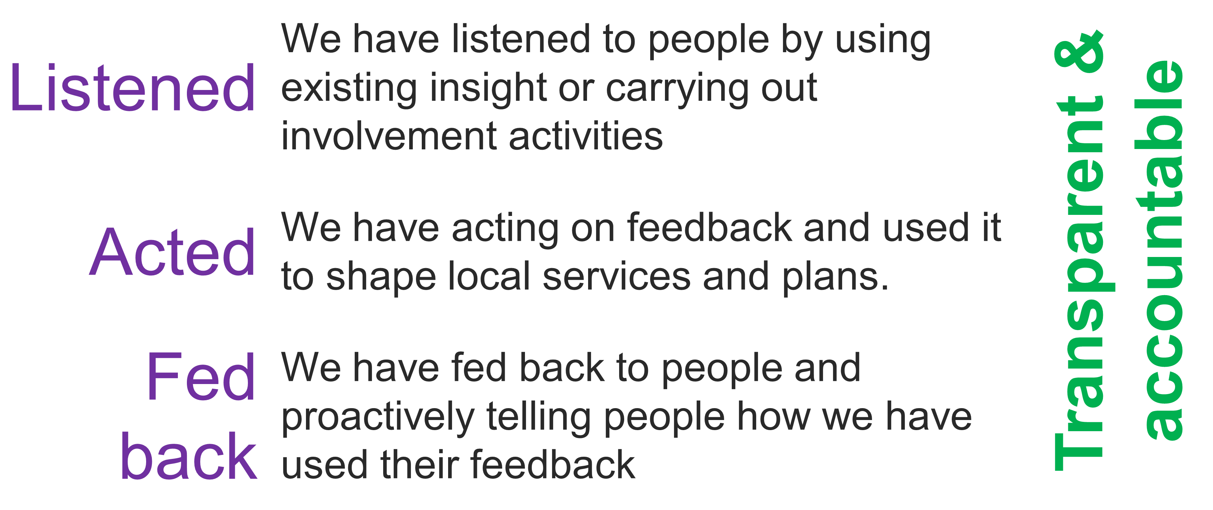
Huma Malik outlined the importance of public representation and assurance. He explained this this would be our approach to ensuring that all our partners and the public were confident that the board has put people at the heart of its decision-making. The group discussed our approach to representation and assurance.

The group look at the current method of representation at the board and how this would provide public assurance.

Currently a representative from the voice and influence team sits on the board for children and young people, to feedback what young people are saying.

The current structure in Leeds we current have the follow youth / community groups:
- GATE
- Getaway Girls
- Outto 18
- Youth Collective
- Transtastic
- Gipsil Groups-The Beck and AIM
- Young Carers
- Catch
- Youth at Shantona
- Muslim Youth Forum
- BARCA VIP Group
- LCH NHS Trust Youth Board
- 2023 Young Leaders
- Tribe Youth Group
- Adopteens
- Young Parents -Shine
- Hamara
- St Lukes Cares
- Youth Association
- Hype and Shout-Marketplace
- Leeds Hospitals Youth Forum
- Youth Service Engage Groups
- Young carers – family action
- Lioneness
Other youth voice opportunities for young people:
- The take over event
- Community youth summits – in which primary and secondary school take part
- Leeds children’s mayor summit
- UK youth parliament
- Leeds youth Council
- Send summit (special schools and send youth forum)
Work with:
- Mindmate ambassadors
- YouthWatch
Which all feed into:
- Children and young people’s scrutiny board
- Children and young people’s partnership
- Children’s board
- Future in Mind
- Children’s champions – community committees
- Co-parenting board ( includes care leavers voice)
- Send Partnership board

This is also a mechanism used to go out and engage with young people on service change through this structure.

Discussion followed as:
- Most people agreed with structure
- There was a concern on how representative each of the participation group where, if we just hearing from same young people each time.

Next steps
The group discussed the next steps for developing an approach to public involvement in the board.
- The feedback will be used to update the insight report
- Participants will be invited to join a small working group to
  - Develop an approach to representation and assurance
  - Explore the gaps in our insight and prioritise involvement

Stay in touch
Stay involved in our work to improve health and care services in Leeds by joining our citywide public network here: Children and Young People - Leeds Health and Care Partnership (healthandcareleeds.org)

For more information about this work please email huma.malik3@nhs.net

