Learning Disability and Neurodivergence Public Involvement Workshop Report
Monday 13 March 2023, 1pm – 4pm
Held on Zoom (online)

On Monday 13 March 2023, the Leeds Health and Care Partnership held a public workshop to discuss mental health care in Leeds. The aim of the workshop was to ‘develop our approach to public involvement in the population board.’ The slide presentation is available on our website here: https://www.healthandcareleeds.org/have-your-say/shape-the-future/populations/ld-nd/

The objectives of the session were to:
- Introduce population health and the board
- Review and agree the findings of the insight report
- Begin planning involvement on the gaps in our knowledge
- Review and agree the draft outcomes for the board
- Agree how we represent people at the board and provide public assurance

The outcomes of the session were
- Understand the role of the board
- Discuss the findings of the draft insight report
- Influence the draft insight report
- Discuss gaps in our knowledge
- Suggest other gaps
- Discuss the outcomes for learning disability and neurodivergence
- Explore ways we can provide assurance that people's voices are heard at the board
- Influence our approach to public representation and assurance on the board

The agenda for the session was:
- Population Health - What are population health boards and what is their role?
- Experience of learning disability and neurodivergence care - What do we know about the experiences of people with a learning disability, neurodivergent, or both, and their family?
- Population outcomes - How do we want things to be different for people with a learning disability, neurodivergence, or both, and their families?
- Public involvement – What does this look like on the board?
- Next steps - What happens next?

The session was attended by 27 NHS, Council, and voluntary sector staff, and members of the public with an interest in mental health. Organisations represented included:
- NHS Integrated Care Board in Leeds (ICB in Leeds)
- Specialist Autism Services
- Advonet
- Healthwatch Leeds
- Leeds City Council
- Leeds Community Healthcare NHS Trust (LCH)
- Epilepsy Research
- Activity Alliance
- Together Women Project
- Forward Leeds
- BARCA Leeds

Workshop feedback
The Chair of the board, Sam Browning, introduced the population health approach and the role of the Learning Disability and Neurodiversity board in Leeds.

Experience of learning disability and neurodivergence care
Chris Bridle from the NHS ICB in Leeds outlined our approach to starting with what we already know about the needs and preferences of people in Leeds. He shared the findings of the insight report and asked for feedback on the themes and gaps. The attendees went into breakout rooms to discuss this.
- There was general agreement with the themes that have been identified in the insight report.
- Timely care – people discussed how it is difficult to get a timely diagnosis, and then any support following a diagnosis. People also noted a delay in getting diagnosis, particularly in children and young people, often as a result of a reluctance to give a diagnosis. It was discussed that this delay can have significant consequences on individuals.
- Person-centred / health inequalities – people discussed that the criteria for diagnosing someone with autism or ADHD are heavily biased towards young white males, which is likely causing gaps in services and in people getting support.
- Health inequality – people discussed that the use of private services to get a diagnosis, it’s creating a two-tier system where people who can pay for a diagnostic service can get seen and those who can’t (often people already experiencing the greatest health inequalities) must wait. This is a big challenge for a system which is focussed on reducing health inequalities.
- Workforce – people raised multiple concerns about a lack of awareness and understanding from health and care staff once a diagnosis is known. People also raised concerns about a lack of understanding and knowledge from the wider public.
- Workforce / person centred – people discussed the need for health and care staff to get more training to ‘treat people as people, not as a diagnosis’ and how to help someone, including ‘where to play you’.
- Information / person-centred / communication – people talked about accessible information being provided based on a person’s needs, not a one-size fits all approach.
- Person centred – people noted that ‘reasonable adjustments’ are delivered inconsistently and not very often. People said it can feel difficult to request or arrange these too.
- Involvement in service development – people discussed the lack of service user involvement in development and design of services has been problematic.
- Information – people noted that there needed to be a better understanding of the wider spectrum of learning disability and neurodivergent conditions, people discussed that awareness and knowledge is often limited to the ‘better known conditions’.
- Wider determinants – people talked about the gap in education, with many teachers not able to recognise learning disabilities or neurodivergence, mistaking it for depression / anxiety and not understanding the challenges these conditions present, both for pupils and their families (social anxiety / behaviour etc.). This sometimes presents itself in very unhelpful reactions, such as threats of prosecution.
- Resources – people discussed the general lack of support for families / parents and a general lack of social support.
- Joint working – people noted that there was a lack of understanding that people can have a learning disability, be neurodivergent and have a mental health condition.
- Wider determinants – people noted that impact a lack of awareness can have, particularly in the workplace, people can often experience being judged and being subject to performance / capability reviews when the person needs a ‘reasonable adjustment’. Some people suggested a campaign that could support people and that organisations would sign-up for, like the ‘dementia friendly’ campaign.
- Health inequalities / wider determinants – people discussed the impact of ethnicity on getting a diagnosis. It was noted that the data for people accessing diagnostic services are skewed towards people who are ‘white’, suggesting that there are people from diverse ethnic communities not receiving diagnoses or getting support from services.
- Communication / information – people talked about the need to promote good and supportive services that are available, including information on how to access them. This is particularly importance for those diverse communities who may be less likely to find this information, or know where to look.

In exploring addressing the gaps in what we know, people discussed examining and comparing the different experiences between gender, age, ethnicity and from LGBTQ+ communities.

Learning disability and neurodivergence outcomes
Eddie Devine from the NHS ICB in Leeds outlined the learning disability and neurodivergence goals that have been developed with partners. These goals explain what we want to achieve to improve the lives of people with a learning disability, neurodivergence, or both and their carers, family, and friends. Eddie asked for feedback on the goals. The attendees went into breakout rooms to discuss this.
- There was general agreement with the learning disability and neurodivergence goals developed by partners in Leeds.
- People felt like the goals were positive statements but thought it was difficult to see how these over-arching statements will be adhered to in practice, at service delivery. A few people noted that ‘it was hard to disagree with them’. Some people found the goals difficult to understand.
- Some people explored how the goals connected to other strategies, it was noted that the goals were the same as those in the Learning Disability Strategy. People also discussed the goals of the mental health population board and the relationship the two boards might have with one another.
- Some people expressed frustration as the goals seemed to be similar to other high-level goals that have been seen before, what’s going to be different this time?
- There were discussions in the groups about what the main function of the Board is and how there will be many groups and organisations delivering the work which will underpin and feed into the broader goals of the Board.
- People liked the idea that it was about what matters to individuals – a good example given was on employment. Employment for some might be important, but others might see this as unachievable or not important.
- Some concerns were raised about how to engage people who might struggle to make a decision or explain what matters. There was agreement that involvement happens on a ‘ladder’ but that most people can be involved in some way. People referred to the Mental Capacity Act.
- It was important that people have support to help them make decisions and get involved. This might come from family, friends or the third sector.
- People said that involvement of family was seen as important as a way of understanding if the goals had been achieved.
- People again noted the importance of having knowledgeable, empathic, and understanding staff.
- It was also discussed that having culturally sensitive support is important so that we can involve people from diverse backgrounds.
- It was suggested that “Listen to, heard, understood and valued” is used in developing any outcomes frameworks.
- Some questions people had about the goals:
  - How will we measure these?
  - How do we separate the goals, as they all overlap and could be incorporated into one statement?
  - How will we ensure that other determinants of health will be included, like housing and education?
  - How are we going to capture ‘what matters to me’ around personalised care, support planning, GP prescribing etc.?

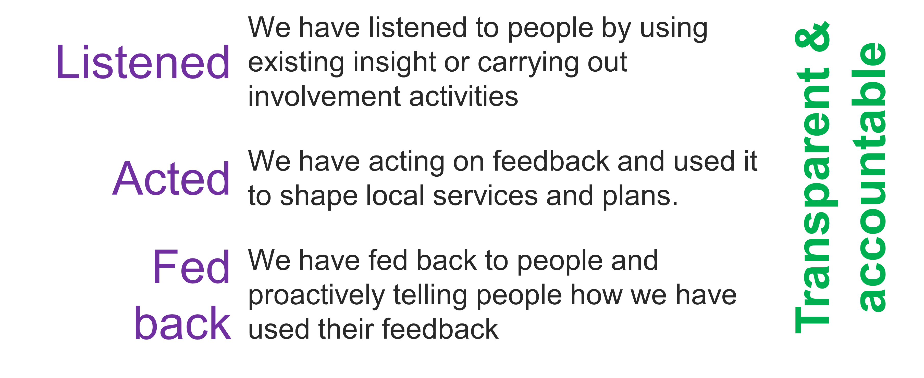
Public assurance and involvement in the board
Chris Bridle outlined the importance of public representation and assurance. He explained this would be our approach to ensuring that all our partners and the public were confident that the board has put people at the heart of its decision-making. The group discussed our approach to representation and assurance. Attendees went into breakout rooms to discuss this.

The group discussed a number of ways we could have representation at the board and provide public assurance.
- Involving people generally
  - People felt we were making a good start in involving people with lived experience.
  - It was at times difficult to explain assurance and representation, it was noted that
  - It was noted that there was minimal, if any, discussion, and involvement of people with a learning disability and that we should look at how best to ensure we do this and do it well.
  - There needs to be a variety of different ways used to offer public involvement to make sure we are accessible to the whole population, e.g., through Zoom, Microsoft Teams, surveys, face-to-face events, and visits to services / organisations to explain who we are, what we do, and how people can, and should be involved.
  - It was important to people that feedback from the board to the population should made in a regular, planned, and timely way, so that people feel they are involved and kept in the loop and that their opinions and voices are heard and valued. This would ensure transparency in the process and help everyone involved to see what is being achieved. This feedback needs to be in a variety of formats to ensure it can be used by as many people as possible, including easy read, videos with subtitles, and through websites etc.
  - The group discussed a potential ‘loop process’, the population feedback to the board, the board form a response and the feedback is shared with the population which includes details on what the board are doing, then opinions on the next topic can be fed back to the board, and so on.
  - Annual health checks could be used as an opportunity to involve people.
  - People queried the diversity of the board, what are members ethnicity and neurodivergent status, people wondered if disclosure could help?
  - It is essential that we map local groups that work with this population – especially those ‘informal groups’ such as Facebook groups for parents of people diagnosed with ADHD.
  - Need to explore how we can improve access to community groups working diverse communities to have conversations with people directly.
  - Need to ensure that timings of activities are flexible (evenings and weekends).
- A public representative attending the board
The group discussed the idea of having a public representative attending each board to hold the board to account for its public involvement. People didn’t feel that one person sat on the board could represent the whole population. The groups discussed that they had some confidence in third sector representatives and Healthwatch but that they weren’t enough to provide assurance. The groups felt that a better way would be to collect opinions and then feed this into the board through a representative.
- An involvement sub-group for the board
The group discussed having a group of public representatives who meet regularly and work with the board on areas of public involvement. This is a method that has been popular in other public involvement workshops. Discussions on this subject suggested that one group for representation might not work, given how different the needs of people can be depending on if you have a learning disability or are neurodivergent. This approach will need more discussion.

Next steps
The group discussed the next steps for developing an approach to public involvement in the board.
- The feedback will be used to update the insight report.
- Agreed that the group should meet again, face to face, to talk about how we can involve people in a meaningful and sustainable way.

Stay in touch
Stay involved in our work to improve health and care services in Leeds by joining our citywide public network here: https://www.healthandcareleeds.org/have-your-say/shape-the-future/join-our-network/

For more information about this work please email adam.stewart1@nhs.net or call 0113 221 7723.

