Long-Term Conditions Public Involvement Workshop
Wednesday 1 February 2023, 9am – 11am
Held on Microsoft Teams (online)

On Wednesday 1 February 2023 the Leeds Health and Care Partnership held a public workshop to discuss Long-Term Condition (LTC) care in Leeds. The aim of the workshop was to ‘develop our approach to public involvement in the population board.’ The slide presentation is available on our website here: https://www.healthandcareleeds.org/have-your-say/shape-the-future/populations/long-term-conditions/

The objectives of the session were to:
- Introduce population health and the board
- Review and agree the findings of the insight report
- Begin planning involvement on the gaps in our knowledge
- Review and agree the draft outcomes for the board
- Agree how we represent people at the board and provide public assurance

The outcomes of the session were
- Understand the role of the board
- Discuss the findings of the draft insight report
- Influence the draft insight report
- Discuss gaps in our knowledge
- Suggest other gaps
- Discuss the draft outcomes for long-term conditions
- Explore ways we can provide assurance that people's voices are heard at the board
- Influence our approach to public representation and assurance on the board

The agenda for the session was:
- Population Health - What are population health boards and what is their role?
- Experience of long-term condition care - What do we know about the experiences of people with long-term conditions and their family? (Our insight)
- Population outcomes - How do we want things to be different for people with a long-term condition and their families? (Our outcomes)
- Public representation and assurance – What does public representation look like on the board?
- Next steps - What happens next?

The session was attended by 20 public and voluntary sector staff and members of the public with an interest in long-term conditions. Organisations represented included:
- NHS Integrated Care Board n Leeds (ICB in Leeds)
- Different Strokes
- Leeds Community Health (LCH) NHS Trust
- Healthwatch Leeds
- National Institute for Health Research (NIHR)
- Active Leeds
- Leeds Teaching Hospital NHS Trust (LTHT)

Workshop feedback
The chair of the board, David Wardman, introduced the population health approach and the role of the Long-Term Conditions Board in Leeds.

Experience of long-term conditions care
Adam Stewart at the NHS ICB in Leeds outlined our approach to starting with what we already know about the needs and preferences of people in Leeds. He shared the findings of the insight report and asked for feedback on the themes and gaps.
- There was general agreement with the themes that have been identified in the insight report
- Health inequalities (location) – people told us that although a focus on areas of deprivation is important, it should be remembered that people who are not from deprived areas may also struggle to access services for varied reasons. An example was given of people living in rural areas struggling to access services locally as they are more centralised. People also told us about the difficulties in accessing services from cross-boundary areas and a lack of joined-up care meaning that patients must navigate a complicated system without help and often conflicting / contradictory information and access criteria.
- Wider determinants (employment) – people told us about the impact LTCs have on people’s work life, including worrying about being able to work, carrying on with their job and needing reasonable adjustments following a LTC diagnosis, progression, or treatment. People noted an inconsistency depending on who you work for to how much support you might get. Having a LTC can be stressful to manage without concerns about finance and livelihood, including navigating benefits systems (such as Personal Independence Payment, PIP).
- Information – people agreed that tailoring information to the audience was important but noted that services often struggle to keep information up to date after they’ve published something.
- The Esther Project was introduced, and people were keen to know more. It was reported that it is a project that began in Sweden and Esther is a persona. Everything that is done in health and care links to Esther with a focus on ‘what to matters to Esther?’ and ‘what does Esther need?’. Kent have adopted the Esther model (https://www.kent.gov.uk/__data/assets/pdf_file/0011/59069/The-Esther-Model.pdf). It focuses on six principles:
  - Security for Esther
  - Better working relations in the entire care chain
  - Higher competence through the care chain
  - Shared medical documentation
  - Quality through the entire care chain
  - Documentation and communication of improvements
- Joint working - People told us that they wanted to understand the boards’ remit, when does one board take over care for someone and how do boards, such as LTC and mental health, reach across multiple populations effectively. People discussed examples of prevention being part of the healthy adult board’s population focus but also needs input from the LTC board to ensure that people are well-informed and working to prevent things such as diabetes.
- Information – people discussed the need for adequate education for people so that they understand their condition enough that they feel confident to manage it, improving their health literacy. People discussed the importance of accessibility in information (including the Accessible Information Standard).
- Communication – people discussed the impact the word ‘discharge’ has and told us that we should move away from using ‘discharge’ as it can have a number of implications, including a perceived ‘discharge of responsibility’ from a provider perspective, leaving patients feeling abandoned. Additionally, people noted that, especially for LTCs, it tends to not be cured, so there will always be a need to be managed in some way. People suggested ‘transition from services’ rather than discharge.
- Joint working - the group discussed difficulties that patients with LTCs face as medicine has felt traditionally siloed by specialisms meaning that joint working is currently inconsistent. This was noted to be particularly true for people with co-morbidities. An example was given where people under 18 have more dedicated focussed care for the whole person, but when reaching 18, it’s managed by the GP who isn’t necessarily equipped / trained to manage a range of LTCs, particularly lesser known / experienced ones, such as Spina Bifida.
- People discussed choice of accessing services including appointments times, locations, and method, including face-to-face and digital options based on need and patient preference. Appointment times and location was noted to be important because of the time it might take someone with a LTC to get going in a morning, as well as getting to said appointment. Appointments first thing were not preferred for many.
- Timely care – people told us that it was important for people with LTCs to access the right care at the right time without facing barriers due to criteria for the service; delays in access to care can lead to deterioration or development of comorbidities.
- Workforce – people told us about challenges in recruitment and retention of staff, particularly when it comes to specialisms in LTCs.
- The group agreed that further work was needed to prioritise the gaps and develop involvement plans

Long-term conditions outcomes
Lindsay McFarlane at the ICB in Leeds outlined the long-term conditions outcomes that have been developed with partners. These outcomes explain what we want to achieve to improve the lives of people with a long-term condition and their carers, family, and friends. Lindsay asked for feedback on the outcomes.
- There was general agreement with the long-term condition outcomes developed by partners in Leeds.
  - People queried what the best ways to measure these outcomes might be. The group discussed that outcome one may be difficult to measure unless a robust means of capturing quantitative (numbers / stats) and qualitative (case studies / experience information) feedback is developed to measure improvement.
  - The group also discussed that outcome one, “I’m as healthy and as well as I can be with my long-term condition” puts a lot of responsibility on the patient, if they fully understand their condition and treatment options. The group suggested changing it to “People living with a long-term condition get the support and tools to enable them to be as healthy as they can be.” The group noted that this relied on the staff knowing and offering all options that are available as patients will not know treatment options unless they are told about them.
- People suggested that demonstrating how services are working together in a more joined-up way would be of use to demonstrate action against the outcomes.

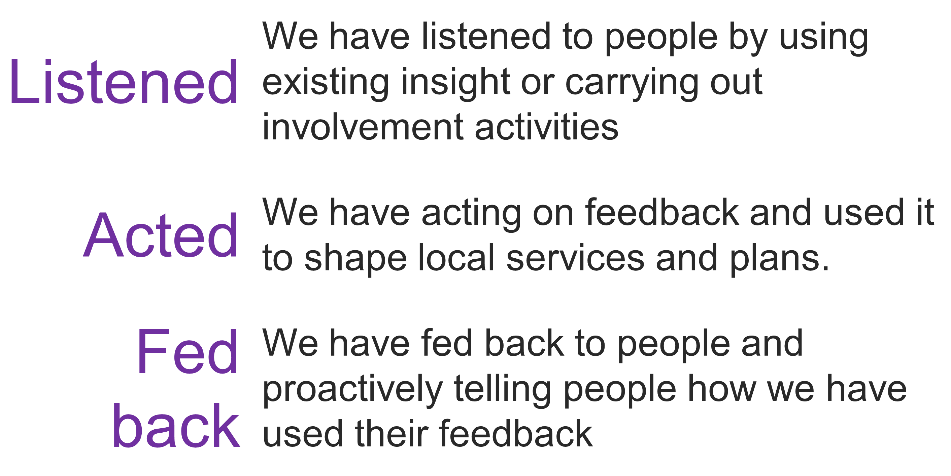
Public assurance and involvement in the board
Adam Stewart outlined the importance of public representation and assurance. He explained this would be our approach to ensuring that all our partners and the public were confident that the board has put people at the heart of its decision-making. The group discussed our approach to representation and assurance.

The group discussed a number of ways we could have representation at the board and provide public assurance.
- A public representative attending the board
The group discussed the idea of having a public representative attending each board to hold the board to account for its public involvement. People didn’t feel that there should be someone sat on the board in isolation. People stated that a critical friend in some form would be useful as well as regular input from people with lived experience, whether that’s someone attending to share their lived experience or the sharing of case studies.
- An involvement sub-group for the board
The group discussed having a group of public representatives who meet regularly and work with the board on areas of public involvement. There was support for this approach, with two members from this group attending board meetings to be the ‘go-between’ the board and this group to provide that ongoing assurance. The group noted that whoever is involved in this sub-group would need to be able to take a step back from their own personal experience to represent the wider population.

People also discussed that people involved in these assurance methods would need a range of support to be involved, this included:
- Regular communications and updates to everyone involved
- Training
- Regular mentoring
People also noted that, more broadly, a range of options should be used to ensure that as many people from the long-term conditions population could be as involved as possible.
People also suggested exploring what involvement mechanisms are already out there to ensure that we know what people are doing currently, and how effective they might be.

Next steps
The group discussed the next steps for developing an approach to public involvement in the board.
- The feedback will be used to update the insight report
- Participants will be invited to join a small working group to
  - Develop an approach to representation and assurance
  - Explore the gaps in our insight and prioritise involvement

Stay in touch
Stay involved in our work to improve health and care services in Leeds by joining our citywide public network here: https://www.healthandcareleeds.org/have-your-say/shape-the-future/join-our-network/

For more information about this work please email caroline.mackay2@nhs.net

