Planned Care Public Involvement Workshop Report
Wednesday 1 March 2023, 1pm – 3pm
Held on Zoom (online)

On Wednesday 1 March 2023, the Leeds Health and Care Partnership held a public workshop to discuss planned care in Leeds. The aim of the workshop was to ‘develop our approach to public involvement in the population board.’ The slide presentation is available on our website here: https://www.healthandcareleeds.org/have-your-say/shape-the-future/populations/planned-care/

The objectives of the session were to:
- Introduce population health and the board
- Review and agree the findings of the insight report
- Begin planning involvement on the gaps in our knowledge
- Review and agree the draft outcomes for the board
- Agree how we represent people at the board and provide public assurance

The outcomes of the session were
- Understand the role of the board
- Discuss the findings of the draft insight report
- Influence the draft insight report
- Discuss gaps in our knowledge
- Suggest other gaps
- Discuss the outcomes for planned care
- Explore ways we can provide assurance that people's voices are heard at the board
- Influence our approach to public representation and assurance on the board

The agenda for the session was:
- Population Health - What are population boards and what is their role?
- Experience of planned care - What do we know about the experiences of people using planned care services and their family? (Our insight)
- Population outcomes - How do we want things to be different for people using planned care services and their families? (Our outcomes)
- Public representation and assurance – What does public representation look like on the board?
- Next steps - What happens next?

The session was attended by 16 public and voluntary sector staff, and members of the public with an interest in planned care services. Organisations represented included:
- NHS Integrated Care Board in Leeds (ICB in Leeds)
- Leeds Teaching Hospitals NHS Trust (LTHT)
- Calm and Centred
- Phone Coop
- Med Tronic

Workshop feedback
The Chair of the board, Stuart Murdoch, introduced the population health approach and the role of the Planned Care Delivery Board in Leeds.

Experience of planned care
Adam Stewart at the NHS ICB in Leeds outlined our approach to starting with what we already know about the needs and preferences of people in Leeds. He shared the findings of the insight report and asked for feedback on the themes and gaps.
- There was general agreement with the themes that have been identified in the insight report.
- Person centred / involvement in service development – people were keen that people with lived experience of services are feeding back regularly on how services are working for them. The group were encouraged by hearing the positive commitment to involving people in the board’s decision making.
- Joint working – people noted that the disconnect in the systems can mean patients falling through gaps in the pathway leading to longer waits or ending up at the back of the waiting list.
- Communication / information / person centred – people fed back the importance of having an open and transparent communication method that helps people understand decision making and the processes, such as booking appointments for treatments. The group discussed how health literacy can be improved by doing this too. It was noted that LTHT’s Outpatient appointments have a high Did Not Attend (DNA) rate; working with patients to understand this could help improve health literacy and understand what is stopping people accessing these appointments. This discussion also touched on the importance of understanding the individual needs and conditions of a person and how that might impact their ability to attend an appointment, or even understand the information they’ve been sent. Understanding, and flagging, people’s communication preferences (such as first language, format etc.), would help improve engagement with services, as opposed to communicating with someone in a language that might not be their primary language (an example of writing to someone who only uses British Sign Language in English will not help them attend that appointment).
- Involvement in care – the group discussed the introduction of new systems at LTHT, such as the Patient Hub and PIFU, the Patient Initiated Follow-Up scheme. These systems will allow people to be more involved in their care. The group discussed the importance of a variety of ways to help people be involved (digital vs. offline, for example).
- Satisfaction / joint working – the group discussed how it can feel like ‘a fight’ to get the right care, navigating multiple services. People noted that some people wouldn’t be able to do this, either because they don’t have the energy, or they don’t know how to.
- Clinical treatment – people discussed the importance of consistency in commissioning policies, particularly in line with NICE guidelines.

Planned care outcomes
Joanna Bayton-Smith at the ICB in Leeds outlined the planned care outcomes that have been developed with partners. These outcomes explain what we want to achieve to improve the lives of people using planned care services and their carers, family, and friends. Joanna asked for feedback on the outcomes:

Outcomes for planned care in Leeds:

- Planned care services are accessible to all regardless of who they are.
- People are supported whilst waiting for planned care services.
- People agree appropriate and realistic shared health goals, and actively participate in their achievement.

- There was general agreement with the planned care outcomes developed by partners in Leeds.
- People discussed the importance of accessibility, and equality of access for all people, particularly in relation to outcome one.
- People noted that importance of evaluating how effective planned care services have been and wondered if it was covered by these outcomes. The group discussed that it would likely be covered by outcome three, but acknowledged that how that is measured needs to be developed.
- The group discussed that it can be difficult to represent everything that is considered in the outcomes, as there’s a lot that sits under each one.

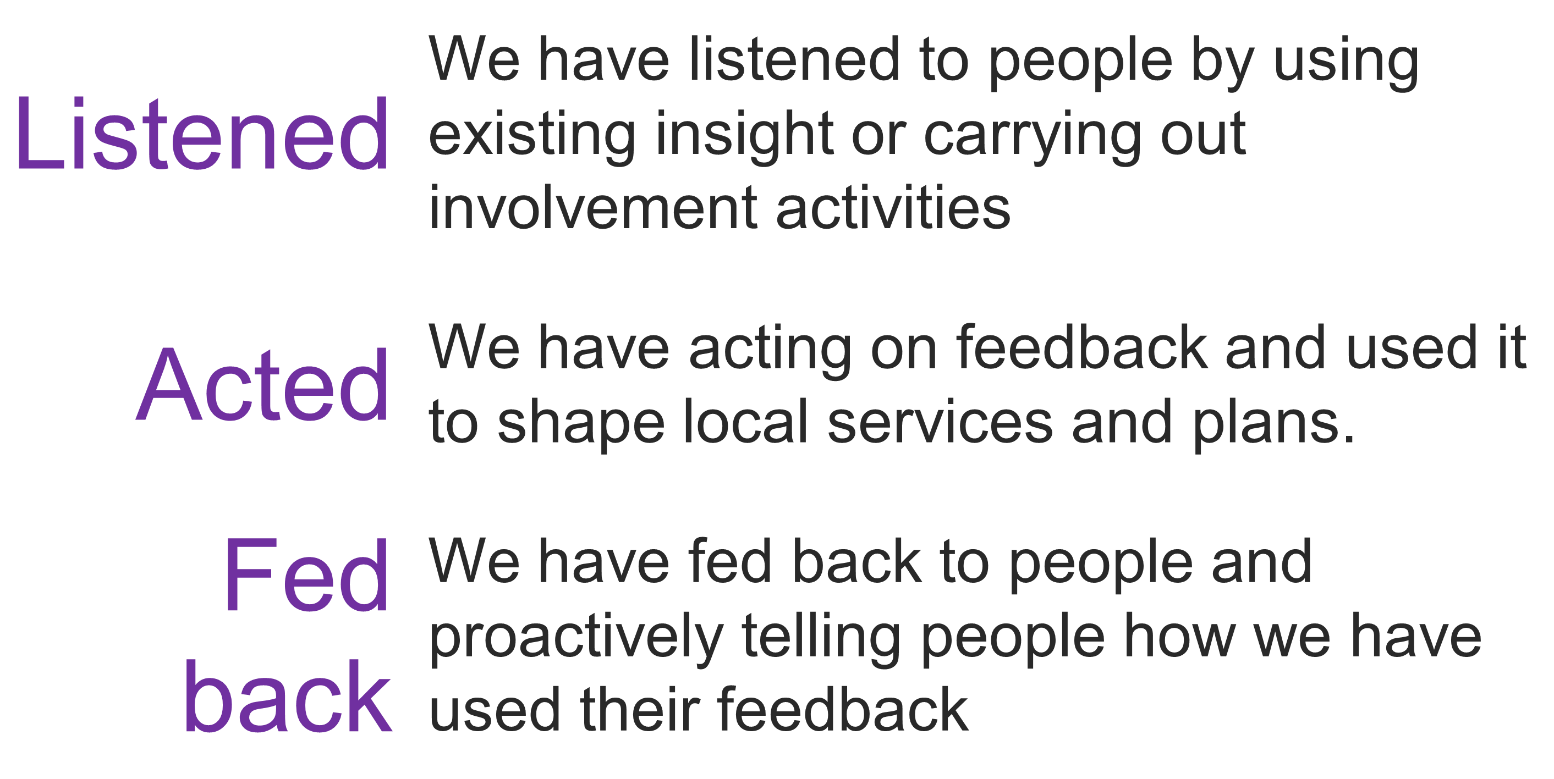
Public assurance and involvement in the board
Adam Stewart outlined the importance of public representation and assurance. He explained this would be our approach to ensuring that all our partners and the public were confident that the board has put people at the heart of its decision-making. The group discussed our approach to representation and assurance.

The group discussed a number of ways we could have representation at the board and provide public assurance.
- A public representative attending the board
The group discussed the idea of having a public representative attending each board to hold the board to account for its public involvement. People didn’t feel that there should be someone sat on the board in isolation. People stated that a critical friend in some form would be useful as well as regular input from people with lived experience, whether that is someone attending to share their lived experience or the sharing of case studies.
- An involvement sub-group for the board
The group discussed having a group of public representatives who meet regularly and work with the board on areas of public involvement. There was support for this approach, with members from this group attending board meetings to be the ‘go-between’ for the board and this group to provide that ongoing assurance. The group noted that whoever is involved in this sub-group would need to be able to take a step back from their own personal experience to represent the wider population.

The group discussed the importance of building trust by demonstrating how people’s feedback and involvement is making a difference to services. The group suggested ensuring there was an ongoing conversation about involvement, rather than seeming like ‘one-off’ opportunities. This will help build trust and encourage further involvement.
The group also discussed the importance of reaching out to lesser-heard communities, going to where they are and working with them in ways that work for them.

Next steps
The group discussed the next steps for developing an approach to public involvement in the board.
- The feedback will be used to update the insight report
- Participants will be invited to join a small working group to
  - Develop an approach to representation and assurance
  - Explore the gaps in our insight and prioritise involvement

Stay in touch
Stay involved in our work to improve health and care services in Leeds by joining our citywide public network here: https://www.healthandcareleeds.org/have-your-say/shape-the-future/join-our-network/

For more information about this work please email adam.stewart1@nhs.net or call 0113 221 7723.

