End-of-Life Public Workshop
Thursday 10 Nov 2022 - 11:00 – 13:00 on Microsoft Teams (online)

On Thursday 10 November 2022 the Leeds Health and Care Partnership held a public workshop discuss end-of-life care in Leeds. The aim of the workshop was to ‘develop our approach to public involvement in the population board’. The presentation and a recording of the session is available on our website here: https://www.healthandcareleeds.org/have-your-say/shape-the-future/populations/end-of-life/

The objectives of the session were to:
- Introduce population health and the board
- Review and agree the findings of the insight report
- Begin planning involvement on the gaps in our knowledge
- Review and agree the draft outcomes for the board
- Agree how we represent people at the board and provide public assurance

The outcomes of the session were
- Understand the role of the board
- Discuss the findings of the draft insight report
- Influence the draft insight report
- Discuss gaps in our knowledge
- Suggest other gaps
- Discuss the draft outcomes for end of life
- Explore ways we can provide assurance that people's voices are heard at the board
- Influence our approach to public representation and assurance on the board

The agenda for the session was:
- Population Health - What are population health boards and what is their role?
- Experience of end-of-life care - What do we know about the experiences of people at end-of-life care and their family? (Our insight)
- Population outcomes - How do we want things to be different for people at end of life and their families? (Our outcomes)
- Public representation and assurance – What does public representation look like on the board?
- Next steps - What happens next?

The session was attended by 20 public and voluntary sector staff and members of the public with an interest in end-of-life care. Two people who couldn’t attend shared their views through a survey. Organisations represented included:
- The Integrated Care Board (ICB) in Leeds
- Leeds Bereavement Forum
- Leeds City Council – Public Health
- Leeds Palliative Care Network
- Volition
- General Practice
- St Gemma’s
- Patient Participation Groups (PPGs)

Workshop feedback
The chair of the board, Gill Pottinger, introduced the population health approach and the role of the End-of-Life Board in Leeds.

Chris Bridle at the ICB in Leeds outlined our approach to starting with what we already know about the needs and preferences of people in Leeds. He shared the findings of the insight report and asked for feedback on the themes and gaps.
- There was general agreement with the themes that have been identified in the insight report
- Covid-19 - People told us that they had mixed experiences of end-of-life care during covid-19. Several people told us that they found it difficult to visit their loved ones during the pandemic.
- Health inequality (learning disabilities) – People told us that the insight report had some gaps around learning disabilities and that it is important for the board to understand the needs of this community.
- Health inequality (mental health) – people told us that there were gaps in the insight around the needs of people with poor mental health
- Health inequalities (gypsy and travellers) – people told us that there were gaps in the insight around the needs of people from the gypsy and traveller community
- Resources – People raised concerns that it took a long time for services to remove end of life equipment after the relative had died. It was acknowledged by professionals that this was a common experience and had an impact on the wellbeing of family and friends.
- Health inequalities (religion) – people raised concerns that services sometimes struggled to meet the needs of people from certain religious communities.
- Information/resources – People told us that carers, friends and family sometimes struggled to access practical support around things like funerals and wills.
- Choice – people told us that sometimes people can change their mind about the place they want to die. If this happens in the last stages of life options can often be limited.
- Choice – people told us that sometimes people can change their mind about ‘do not resuscitate’. If this happens in the last stages of life options can often be limited.
- The group agreed that further work was needed to prioritise the gaps and develop involvement plans
Helen Smith at the ICB in Leeds outlined the end-of-life outcomes that have been developed with partners. These outcomes explain what we want to achieve to improve the lives of people at end of life and their carers, family, and friends. Helen asked for feedback on the outcomes.
- There was general agreement with the end-of-life outcomes developed by partners in Leeds.
- People felt that the workshop was a useful way of exploring and checking the outcomes.

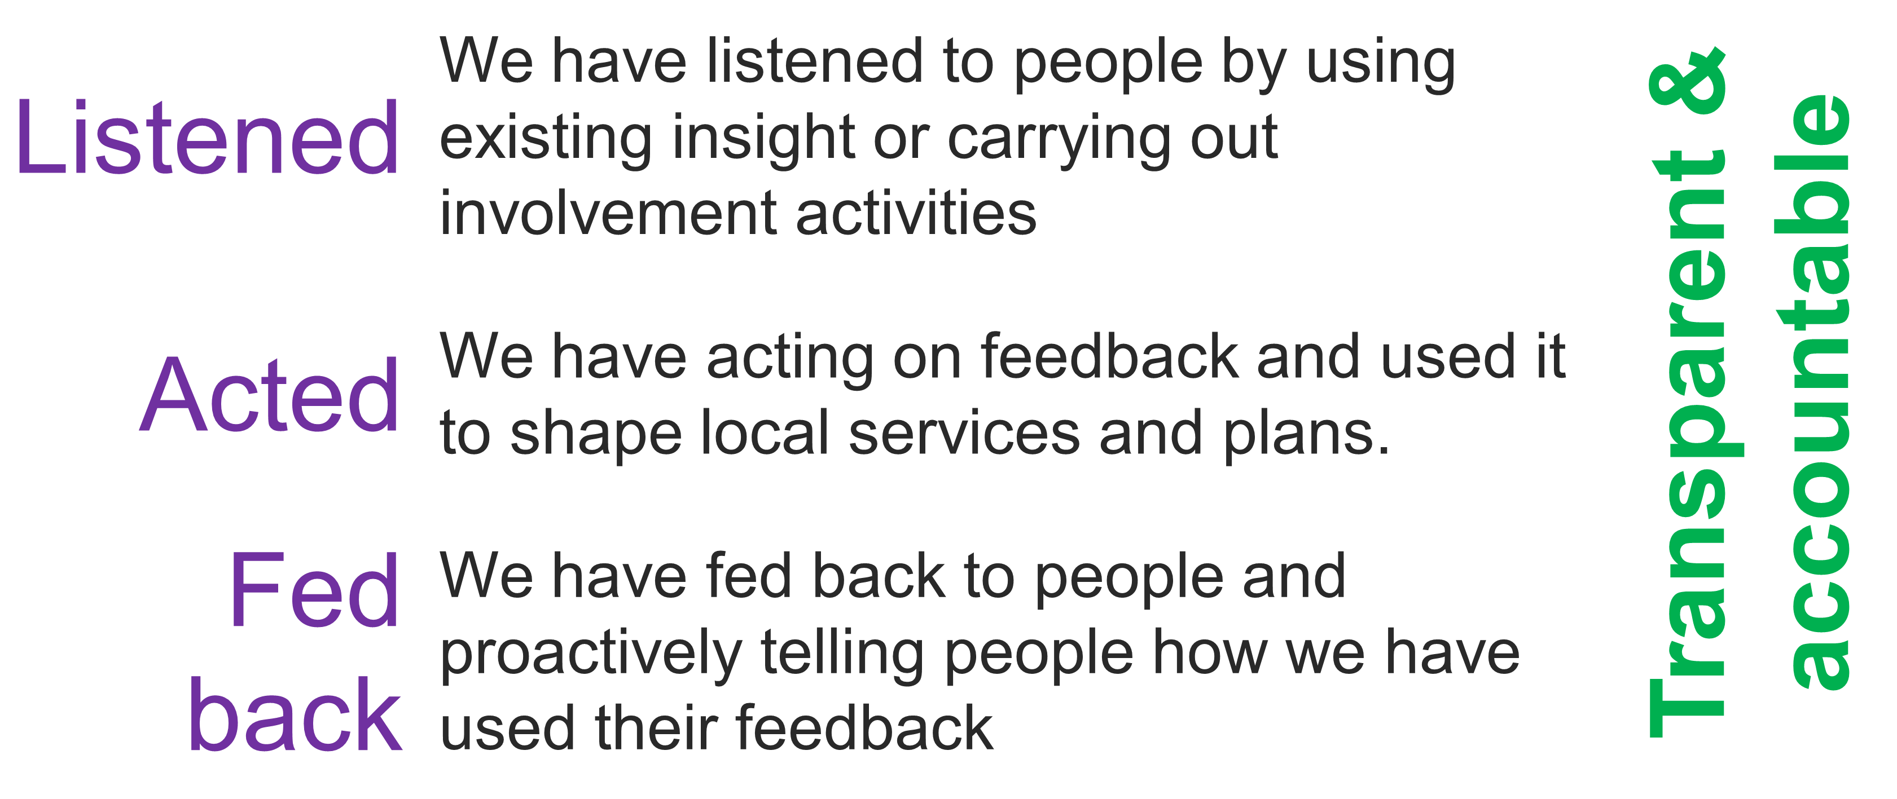
Chris Bridle outlined the importance of public representation and assurance. He explained this this would be our approach to ensuring that all our partners and the public were confident that the board has put people at the heart of its decision-making. The group discussed our approach to representation and assurance.

The group discussed a number of ways we could have representation at the board and provide public assurance.
- A public representative attending the board
The group discussed the idea of having a public representative attending each board to hold the board to account for its public involvement. There were mixed views around this. Some people felt that this showed that the board valued the views of the public. Other people had concerns around how one person could represent the views of a diverse community and about the pressure and commitment needed for this role.
- An involvement sub-group for the board
The group discussed having a group of public representatives who meet regularly and work with the board on areas of public involvement. There was general support for this approach but agreement that it needed developing.
- Different public representatives attending the board
The group discussed members of the involvement subgroup taking it in turns to attend the board to represent the wider public. There were mixed views about this approach. People liked that it would share the responsibility of the role but had concerns about consistency.

Next steps
The group discussed the next steps for developing an approach to public involvement in the board.
- The feedback will be used to update the insight report
- Participants will be invited to join a small working group to
  - Develop an approach to representation and assurance
  - Explore the gaps in our insight and prioritise involvement

Stay in touch
Stay involved in our work to improve health and care services in Leeds by joining our citywide public network here: https://www.healthandcareleeds.org/have-your-say/shape-the-future/join-our-network/

For more information about this work please email chris.bridle@nhs.net

