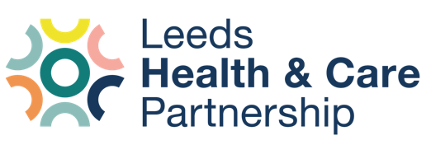
Item Lead(s): Adam Stewart
Author(s): Adam Stewart

Report of: Leeds Office of the NHS West Yorkshire Integrated Care Board (ICB)
Report to: People’s Voices Partnership (PVP)
Report title: Reviewing ‘Involving You’ and our future reporting

Reviewing ‘Involving You’ and our future reporting
Purpose of this report
The aim of this report is to summarise and address the feedback collected from a range of stakeholders who shared their thoughts on the ‘Involving You’ documents. The report will identify themes for the Leeds Health and Care Partnership to consider with how it reports on its involvement activities.
Background information
What is Involving You?
Involving You is a look at some of the work that health and care organisations have done over the course of a year to involve local people in shaping services in Leeds. It is a document that is written for anyone with an interest in our involvement work. This includes patients, members of the public, health and care staff, voluntary sector organisations, service providers and the local authority (Leeds City Council).
It’s important to understand the needs of local people and we use their feedback to improve our services. The aim of Involving You is to demonstrate how we are working with local people to develop and provide high quality, safe, and kind services.
Involving You has been developed and co-produced with patients and the public for the last few years. We have always involved people in its development. Following feedback from the people of Leeds, the report is currently presented in two versions: a full report and a shorter summary document.
What did we do?
Originally, the report was a focus on the involvement activities of NHS Leeds Clinical Commissioning Group (CCG). Now, as we have become an Integrated Care System in West Yorkshire, we are working much more closely with our partners in Leeds. This year's Involving You (2021-2022) report is a celebration of our partnership working in Leeds, with examples of involving local people from different organisations in Leeds.
Following feedback from NHS Leeds CCG’s Reader Group and other stakeholders, we produced a range of Involving You documents for April 2021 – March 2022:
- Standard Involving You ‘main report’ (48 pages)
- Involving You: Summary (12 pages)
- Black and white version of the two documents
- Plain-text, web versions of both documents (viewable online here: https://www.healthandcareleeds.org/publications/involving-you-2021-2022/)
To help us assess the Involving You documents, we asked people who received them to tell us what they think about them. We created a survey asking people to share their feedback and tell us their preferences.
The survey was available online and in paper formats. The survey was included in all mailouts both electronically and by post when the Involving You documents were circulated. People who received paper copies also received a Freepost envelope so they could return it without a cost to them. Alternative formats of the survey were available on request.
People were asked to confirm they had read both the main document (48 pages) and the summary document (12 pages) before completing the survey. Given the length of the documents, the survey was open for eight weeks from the start of June through until the end of July 2022.
About this report
Based on feedback we’ve received previously; we have presented the themes and considerations from the survey first (see the next page). In depth detail on the questions can be asked after that in ‘results’ and ‘key points.’
Get in touch
If you have any ideas, questions or thoughts based on this report, please contact:
Adam Stewart
Senior Insight, Involvement and Engagement Advisor, Integrated Care Board in Leeds
Tel: 0113 221 7723
Mobile (call or text): 07393 469 534
Email: adam.stewart1@nhs.net

Themes
111 completed the survey and shared their feedback. People told us:
What people liked
- The overall design, including the layout, colours and content.
- The documents were good at providing an overview of the different organisations and how they’ve involved people.
- The infographics and images used throughout were good at breaking up the content and conveying messages.
- The inclusion of the contact details and how to get in touch was helpful.
- They liked how easy to read and accessible the documents were.
- The summary document was informative, concise, and good at conveying the key messages.
- Most people said the documents helped them understand how health and care organisations were working together.
- The majority of people also felt more interested in getting involved in the future.
What they think could be improved
- There is a lot of information included and that the main document is certainly too long for most people.
- Because of the length, they felt they couldn’t share the documents with their friends, family and wider networks.
- They wanted to see more of a focus on the current issues people are facing (such as long waiting times, access to GP appointments, etc.) and what is being done to address them.
- They also said they’d prefer a focus on conditions rather than specific orgnansiations with a focus on the difference being made.
- They suggested a number of ways they’d like to ‘reporting’ done in the future, including summary documents and videos, feedback workshops and articles in local media (newspaper, TV and radio).
Next steps
We will share this report and its learning with the People’s Voices Partnership (PVP).’ The report will inform how we look to communicate with people about how we are involving them and how that makes a difference. We will provide updates on: https://www.healthandcareleeds.org/get-involved/your-views/reviewing-iy-2022
Results
Who did we hear from?
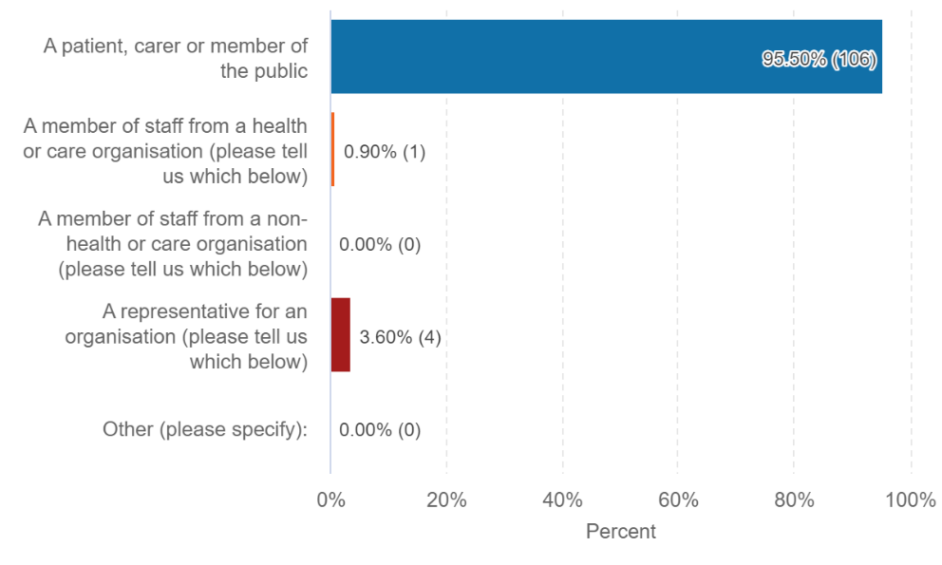
We received 111 responses to the survey.
- 106 responses (96%) were from a patient, carer or member of the public.
- One response (1%) was from a member of staff of a health or care organisation.
- We did not receive any responses from a member of staff from a non-health or care organisation.
- 4 responses (4%) were from someone representing an organisation. Organisations mentioned in the responses in total included:
  - Leeds and York Partnership NHS Foundation Trust
  - Leeds City College
  - Morley and District Lions Club
  - Leeds Community Healthcare NHS Trust
  - Leeds Involving People
  - Garforth Medical Centre Patient Participation Group

Key Points
What do you think of Involving You?
We asked people if they had heard of Involving You before reading the documents to complete the survey. Of the 111 people who filled in the survey:
- 34 people (31%) were aware of Involving You.
- 53 people (48%) were not aware of Involving You.
- 24 people (22%) were not sure if they had seen Involving You previously.

First impressions
We asked people to share their first impressions of the Involving You documents.

“I was most impressed by the Involving You documents. A very professional booklet that all involved should be proud of. It took me a few days to read through and digest - well worth it. Well done giving a positive attitude.”
“Very motivating to get involved in service improvements. It demonstrates how much work is going on in the background and it would be great to share these on a wider scale.”
“Very wordy and bright graphics, but does it really do anything to resolve any of the current health care issues? Actions are far better than words.”
“The documents are accessible, but my GP isn’t.”
The majority of people had positive first impressions of the Involving You documentation. They told us:
- The documents were interesting, informative, clear, easy to read and well written.
- They liked how colourful and bright it was.
- They liked the design and the graphics used and that it was engaging, eye-catching and well presented.
- The documents were comprehensive and detailed with a lot of information.

Some people had negative first impressions of the Involving You documents. They told us:
- The main Involving You document was too long. People liked the summary document’s length.
- About concerns they had about the time, financial and resource costs that the documents take to produce.
- The documents don’t reflect the state of health and care services and don’t accurately address the issues for people.
- The reports are tokenistic when it comes to actually enacting change and were doubtful of their intentions.
- Some did not like the graphics used.
- The documents were complicated and felt that there is a lot to understand and take in.
Is Involving You accessible?
We asked people if they thought the versions of Involving You were accessible for them.
- 78 people (71%) said that they found Involving You accessible.
- 12 people (11%) said they did not find Involving You accessible.
- 20 people (18%) said they found it accessible in some ways and not in others.

We asked people to tell us more about their answer:
- “The documents are user friendly and understandable for everyone.”
- “Easy to open on a mobile device.”
- “I am dyslexic and I don’t have a fancy phone so if they go to download they take up memory.”
- “I rely on my phone and iPad for internet. My Wi-Fi is quite slow and I struggle with online content.”
- “The graphics and charts were useful to make the documents more accessible.”
- “Easy to read and well set out.”
- “48 pages is rather long.”
- “Good contents, page numbering, clear sections.”

Are you more interested in getting involved?
We asked people, after having read the Involving You documents, were they more or less interested in seeking out involvement opportunities in Leeds.
- 64 people (58%) said that they were a little or much more interested in finding involvement opportunities in the city.
- 29 people (27%) said they were a little or much more disinterested in looking for involvement opportunities in Leeds.
- 18 people (16%) said they were unsure about seeking out involvement opportunities.

Better understanding
We asked people if, after reading the Involving You documents, they had a better understanding of the ways health and care organisations involve people and the difference that involvement makes.
- 85 people (77%) said that they had a better or a little better understanding.
- 17 people (15%) said that they did not have a better understanding.
- 8 people (7%) said they were not sure if they have a better understanding.
We asked people to tell us more about their answer:
- “There are many areas of involvement that I was unaware of.”
- “Each initiative clearly sets out what it’s about, how you can get involved and to what extent and what has been achieved so far or is aimed to be achieved in the future.”
- “I'm afraid this is all falling to the trap - beloved of politicians of all sides - of banging on about giving people choice and involvement, when what they want is simply services that work when desperately needed. Of course, choice and involvement are nice after that, but of no value whatsoever without that first.”
- “I had no idea of the variety of projects going on throughout the city and it is exciting to see how these develop.”
- “I can see how the organisations involve people but not so much about the difference it makes to people.”
- “It shows a multiplicity of organisations all churning out paperwork and remote from the day-to-day activities of health care.”
- “It can no longer be up to just one organisation to provide all the health answers, and solve people's health problems. The document does make it clear that partnership working is the way of solving these problems.”

What did people like about Involving You?
We asked people to tell us what they liked about the Involving You documents. In addition to the comments made that were similar to their first impressions (see above), people also told us:
- They liked the overall design, including the layout, colours and content.
- The document provided a good overview of the different organisations and how they’ve involved people.
- The infographics and images used throughout were good at breaking up the content and conveying messages.
- The inclusion of the contact details and how to find out more and get in touch was helpful.
- They liked how easy to read and accessible the documents were.
- The summary document was informative, concise and good at conveying the key messages.
“The context giving short facts and statistics about the area was interesting as was the coverage (if a little bewildering) of all the groups, organisations, trusts, and committees.”
“The summary document allowed me to skim through the key points I'd read about in the page document. Titles were useful - easy to find the information I was looking for. Useful section on how I can get involved.”
“Well set out. Easy to find relevant sections. Comprehensive. Good linking; lots of contact details.”

What did people think Involving You could do better?
We asked people to tell us how they thought the Involving You documents could be improved. In addition to the comments made that were similar to their first impressions, people also told us:
- The length of the main document is too long and suggested that the content could be reduced by avoiding any repetition, being more concise and streamlining the content.
- The document doesn’t appropriately address the issues that people are currently facing in health and care services at the moment (waiting times, GP access etc.) and what is being done to address them.
- People queried the value in producing the Involving You documents and whether the cost associated with its production could be best spent elsewhere. It’s important that any documentation is clear about its purpose; why is it being produced and that it adds value and makes good use of the ‘Leeds pound’.
- Ideas for additional content or ways of presenting the information, including:
  - A content index at the back of the main document
  - More case studies about how involving people is making a difference and from people being actively involved.
  - Exploration of the costs and how projects were funded which could help address potential queries about initiatives and concerns around “will they ever happen?” and “how will this be achieved?”.
  - Adding location names to the map used to explore where we have been over the last year.
  - Summary of services on a page or two with contact information and details about which services they provide (e.g. clearer signposting on where to find help for dementia care etc.).
  - Terminology ‘checks’ throughout and understanding why certain terms are used, such as “people with lived experience”.
  - Diagrams and descriptions of organisations.

“Spend the money on health care, not producing "stories" about it.”
“A few case studies would make it more real and interesting. More detail from people/patients on how things were improved by Involving You. The fine detail was not explained it was very brief for each section. It was not clear how exactly things were improved in every section for example - Transforming community mental health services is a huge task but there was very little detail other than 40 people involved.”
“Identify, accept and tackle some of the real key issues facing medical care and GP services in particular as a starting point; the process as a whole is clearly broken, but the GP service as the first point of contact, should and could work far better for the benefit of all.”

Sharing Involving You
We want to make sure that Involving You is reaching as many people as possible. We asked people to tell us if they would consider sharing the Involving You reports they read with friends, family or in their wider community.
- 29 people (28%) said they would share the reports in their personal networks and in the wider community.
- 44 people (43%) said they would not share the reports in their personal networks and in the wider community.
- 30 people (29%) said they were unsure if they would share the reports.
We asked people to tell us more about their answer. They told us:
- If the reports were easily shareable (such as on social media or via email). Directions or prompts / mechanisms to aid with easy sharing would be useful (such as forwarding links in emails).
- There is too much information to share; that the main document is too long for people to be interested.
- They don’t think their friends and family would be interested in the current content, they’d be more interested in content that is more directly about current issues or about specific conditions / illnesses, rather than organisations.
- Shareable ‘sections’ or bite-size versions of the document would be easier to share; relevant sections could be shared rather than the full document with a focus on verified information and the key information.
- Some places that they would like to see reports, or where they would share the documents:
  - Local Patient Participation Groups (PPGs)
  - Libraries
  - Community centres
  - GP practices
“It is not something I feel would be of interest to my circle of friends and family. To be honest, the whole concept looks improbable, as it is trying to be all things to all men. The figures quoted mean nothing without credible references (15,500 extra GP appointments per month - come on!!)”
“I think it’s almost impossible to try and explain how the system hangs together in this document. I don’t think my friends and family are interested in the different organisations. If possible, it would be better to focus on what involvement actually is, its importance and value and then link to the actual subjects/projects/services.”

What content should we be including in Involving You?
We asked people to tell us the type of content and information they’d prefer to see in a document or report such as Involving You. This could be in addition to the content already included or a focus on other areas of interest. People told us they’d like to see:
- A focus on each area in Leeds (what’s happening in different areas).
- Input from Leeds City Council on health and care related issues.
- Focus on the current issues in health and care; acknowledging the issue, including when things have gone wrong and the plan to address them.
- Volunteering opportunities.
- Timelines / timescales for projects.
- Noting the outcomes of a project; how will something make a difference and how will it work (i.e. where are staff coming from? etc.).
- ‘Credible references / sources’ for stats.
- Exploration of the finances (how is the project being funded, projected costs etc.).
- A focus on prevention including guidance and signposting to where to get help regarding the health conditions / issues discussed.
- Linking involvement activity with upcoming known health and care issues; work that is being done to address them (such as diabetes, dementia, mental health etc.).
- Case studies, including examples of in-practice good practice (example given of a GP practice that is doing something and the difference it makes, in a format that can be shared for others).
- Evidence of ‘actual change’.
- Addition of alternative contact methods for projects (rather than just a website link).
“Current income for the various services, and projected costs. We are in financially difficult times, yet the proposals are made out to be easily attained. How many more staff will be needed? How long will it take to train them?”
“There appears to be little about prevention. That is both for individuals (e.g., fall prevention or loneliness), or a community approach (other than open spaces).”
“As an attempt to coordinate services around health and care issues, it was amazing how little mention there was of the Social Services either the adult or children's services.”

Future formats
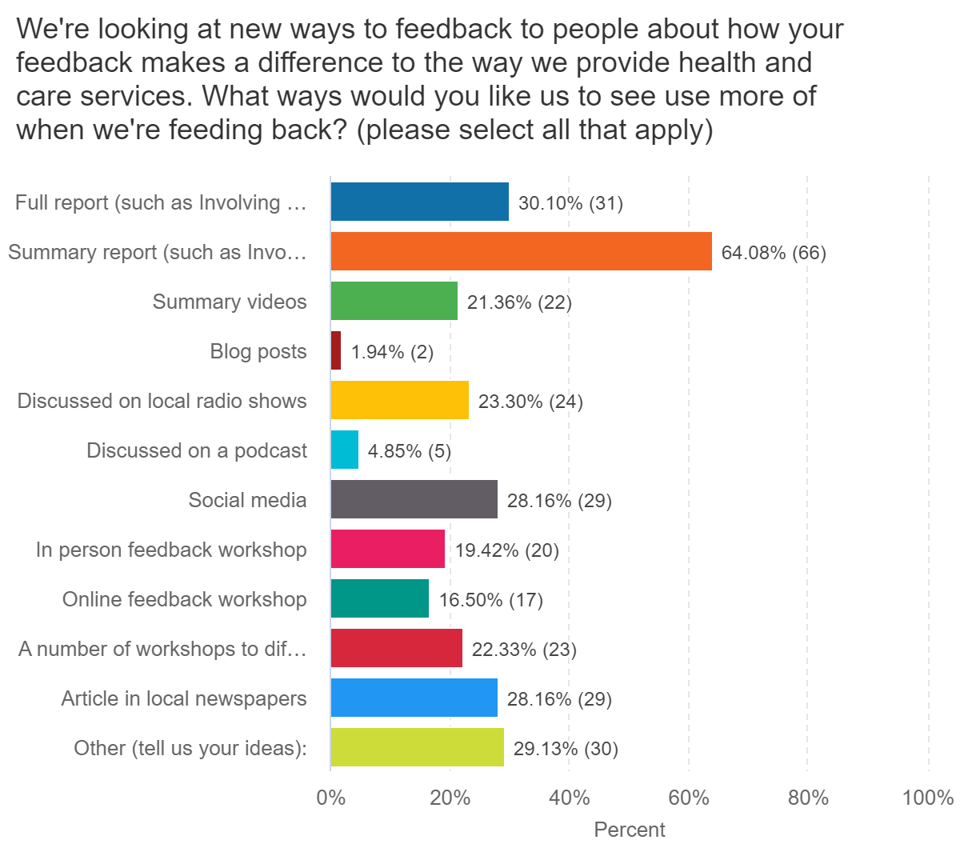
We asked people to tell us the formats they would like to see reporting in the future. People could suggest more than one option.
- 31 people (30%) said they would like to see a full report, such as the current Involving You (taking into consideration any feedback to improve).
- 66 people (64%) said they would like to see a summary report, such as the current Involving You Summary report (taking into consideration any feedback to improve).
- 22 people (21%) would like to see summary videos used.
- 2 people (2%) said they would like to see blog posts used.
- 24 people (24%) said they would like hear information disucssed on local radio shows.
- 5 people (%) said they would like to hear the information disucssed on a podcast.
- 29 people (28%) want to see social media used.
- 37 people (36) would like information discussed at a workshop, with 20 people (19%) wanting an ‘in-person’ workshop and 17 people (17%) preferring an online feedback workshop. 23 people (22%) would like to see a series of feedback workshops taking place in different places in Leeds, a “feedback tour”.
- 29 people (28%) would like to see a report in the local newspapers.

30 people (29%) selected ‘other’ and told us their thoughts and ideas:
- Articles / posters in the community, including:
  - GP practices and other health care settings (such as hospitals)
  - Community halls
  - Local libraries
  - Community noticeboards
  - Health and sport centres
  - Schools and nurseries
  - Parish and Town Council newsletters / meetings
- More website page reports
- Adverts on / in buses
- Paper flyers
- Calendar / Look North TV
- Make it meaningful, substance over style
- Stands at galas / fetes / events in local areas
- Attend shopping centres

