PPG Toolkit V1.0
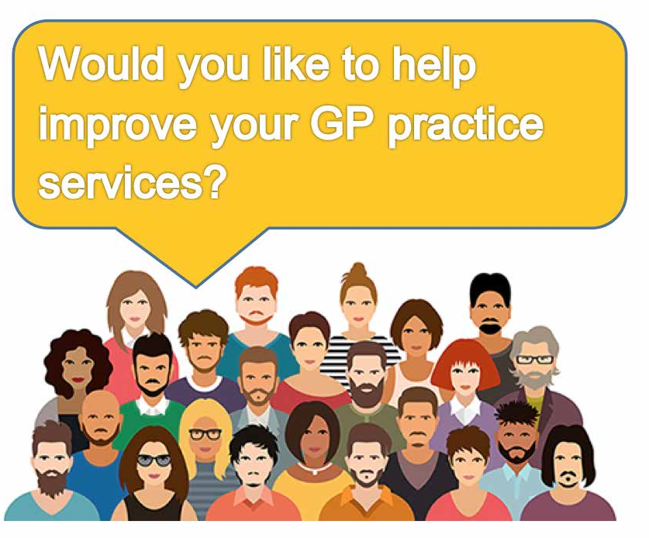

Have you ever thought about joining our Patient Participation Group (PPG)?
A PPG is a group made up of volunteer patients and members of practice staff who work together to improve the experience of patients using the practice.
To find out more, please contact XXXXXX XXXXX the Practice Manager on 0113 XXX XXXX or email us on XXXX. XX@nhs.net or speak to a receptionist.

