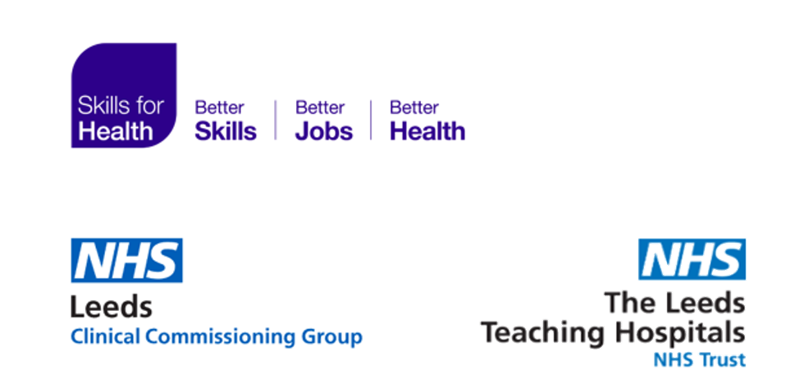



NHS Leeds CCG and LTHT COVID Vaccination Patient Survey

August 2022

Contents

1 Foreword 3

2 Executive Summary 4

3 Background 6

4 Methodology 7

5 Survey findings 8

5.1 Respondent Demographics 8

5.1.1 Gender 8

5.1.2 Deprivation 9

5.1.3 Age 10

5.1.4 Ethnicity 12

5.1.5 Disability 13

5.1.6 Language 14

5.2 Location 14

5.2.1 Vaccination Centres 15

5.2.2 Location experience ratings 16

5.3 Vaccine Dose 17

5.3.1 Dose received 17

5.4 Experience of receiving the vaccine 18

5.4.1 Comments by Sentiment 18

5.4.2 Examples of respondents’ sentiments 20

5.4.3 Customer Experience - Rating Over Time 21

5.4.4 Customer feedback – what could have been better 22

5.5 Revised Vaccination Decision 23

5.5.1 Reasons for changing decision 24

5.5.2 Key themes arising regarding vaccine decision 24

5.5.3 Revised Vaccination Decision Demographics. 26

5.6 Responding to Patient Feedback 29

6 Key takeaways 30

7 Annexes 32

Survey Copies 33

Example of Respondent Quotes 39

# Foreword

On 8 December 2020, 90-year-old Margaret Keenan received the world's first approved COVID vaccine, at University Hospital in Coventry. On the same day, 80-year-old Sylvia Harris, NHS hospital ward housekeeper, was the first person in Leeds to have her COVID vaccination at St. James’s Hospital. Margaret and Sylvia’s vaccinations marked the start of the biggest, most challenging vaccination programme ever undertaken in the UK.

In Leeds, the programme was met with an incredible response from the NHS, GPs, pharmacies, the council, community and voluntary organisations, thousands of volunteers and from local people who came forward to receive the vaccination – it was #TeamLeeds at its absolute best.

As the scale of the programme became clear, members of the city’s People’s Voices Partnership, which brings together staff working on public involvement in local health and care organisations, began to discuss how to capture feedback from Leeds residents attending centres for their COVID vaccinations.

From these conversations two separate but aligned surveys developed - Leeds Teaching Hospitals NHS Trust’s Friends and Family Test, and NHS Leeds Clinical Commissioning Group’s online survey for community-based vaccine centres. Both surveys were launched in February 2021 and within a year had together gathered almost 30,000 responses from the people of Leeds.

The early days of developing, managing and analysing the surveys were hectic and emotional. It is easy to forget how scared people were and how grateful many of the initial cohorts were to be able to leave their homes and come to get their vaccinations – as the most vulnerable to COVID, many had been shielding for nearly a year before the vaccination brought hope for a return to normal life. People’s responses in the surveys reflected those emotions, and it felt important that people were able to share and reflect on that in the surveys.

I am immensely proud to have been part of the #TeamLeeds vaccination programme, and I know that every single person who has been involved feels the same. On behalf of the programme board, I am therefore pleased to be able to bring you this report on people’s experiences of the vaccination programme. I would like to thank our involvement colleagues for initiating this work and the team at Skills for Health for managing to extrapolate key findings from so many personal testimonies. There is much to build on and learn from in the report, and we’ll be using this learning as we continue to deliver and develop the vaccination programme in the city.

But our main thanks go to the huge numbers of committed and dedicated staff and volunteers, who straight away established an almost military-style operation to protect the people of Leeds, and to the people of Leeds themselves for turning up in their thousands to protect themselves, their loved ones, and their communities, and for taking the time to tell us how the experience was for them. We are truly grateful.

**Sam Prince, Senior Responsible Officer, Leeds COVID-19 Vaccination Programme**

# Executive Summary

NHS Leeds Clinical Commissioning Group (CCG), Leeds Teaching Hospitals NHS Trust (LTHT) and Leeds Community Healthcare NHS Trust (LCH) joined together with the purpose of giving patients, who received their COVID vaccinations, the voice to express and share their experiences. Two surveys were launched, one from NHS Leeds CCG and one from LTHT, receiving a total of nearly 30,000 responses.

Skills for Health were commissioned to analyse the data output of this survey. This report identifies the key learnings from the patients’ feedback and highlights the remarkable achievement of the largest vaccination programme in the UK.

The two surveys were combined, matching questions and results where possible, to analyse and extract key outcomes and learnings from patients’ experience. Both quantitative and qualitative data analysis was undertaken using Microsoft Excel, SPSS and NVivo.

Overall, the respondents rated the experience of receiving their vaccine very highly, giving an average score of 9.8 out of 10. The majority of respondents from the survey were female (54.1%). When considering participants’ experience scores, the only slight demographic differences were along the lines of age, ethnicity, location of vaccine, and dose of vaccine.

Those who stated they had a disability were slightly more likely to give a lower experience score than those who said they did not have a disability. The lowest experience score by deprivation came from those in the most deprived areas. However, this score was still 9.6, only 0.2 lower than the overall average of 9.8.

A total of 101 vaccination centres were identified from the survey responses with Elland Road, Thackray Museum and Alwoodley Medical Centre vaccination sites covering 79% of respondents’ location for their vaccine.

Respondents were asked to provide the date they received their vaccine. The responses covered a span of 15 months between December 2020 to February 2022. During this time, respondents’ average vaccination experience score fluctuated between 9.2 and 9.9. When comparing the participants’ experience score against the national new COVID cases, reported by the Office of National Statistics, a relationship can be seen between low respondent experience scores and high national COVID cases.

Key Takeaways

Respondents were generally very positive about their experience of receiving their vaccine. Patients scoring their experience of the second vaccine gave a higher score for their booking experience compared to those who were being vaccinated for the first time.

“From beginning to end everything has been great, but the cherry on the cake was the nurse giving the vaccine - so calm and professional - amazing... if everyone's had that experience... Wow!”

Of the sample, 7.7% were from a Black, Asian and Minority Ethnic (BAME) background and although the overall average scores across all groups were very good, respondents from a BAME background were more likely to give a lower experience score. When considering gender, there is a similar outcome for males and females. Females were more likely to give a lower score (between 1-5 on a 10-point scale), compared to their male counterparts.

The vast majority of respondents said that they had always intended to get the vaccine. For those who were initially hesitant to be vaccinated, the main influence to change their opinion was the COVID restrictions that were in place. Also, ‘family and friends’ were a major influencer. The common themes are either pressure from individuals or concerns over protecting the health of loved ones. Additionally, regarding respondents’ change of view on the vaccine; there is a noticeable difference in those people with a disability or from a BAME community.

# Background

NHS Leeds Clinical Commissioning Group (CCG) and Leeds Teaching Hospitals NHS Trust (LTHT) worked together to collect data in line with the existing Family and Friends Test, with LTHT launching their survey at mass vaccination centres Elland Road and Thackray Museum on the 16 February 2021. The NHS Leeds CCG survey launched on 19 February 2021 and collected feedback from vaccination clinics in General Practice (GP) surgeries and other community settings including the roving bus and pop-up clinics.

The LTHT survey has received over 23,000 responses and the CCG survey, over 6,000 – approaching 30,000 responses in total.

Although the two surveys were not the same, they both asked respondents to score their experiences of getting a vaccine, and space was provided for free text comments.

Both surveys collected equality monitoring information – gender, age, ethnicity and disability. This level of detail helps to highlight differences in experience between different protected characteristics groups.

In order to provide insight and learning for a number of audiences on a global, national, and local scale, NHS Leeds CCG* commissioned Skills for Health (SfH) to carry out quantitative (stats and responses that can be ‘scored’) and qualitative (people’s comments) analysis of the data from the survey responses. The learnings from this analysis were to then be presented as the following written report.

*Please note that NHS Leeds CCG as an organisation was replaced by the NHS Integrated Care Board in Leeds on 1 July 2022.

# Methodology



“I was incredibly anxious due to having needle phobia. I explained this to the nurse and that I was having Cognitive behavioural therapy (CBT) around this. Two nurses supported me and they were extremely kind and compassionate and made the whole experience as positive as it could possibly be for me. Be proud - you are amazing!!”

In order to analyse both sets of data from the two individual surveys, both datasets were combined to form one (where similar data was available). This involved making some adjustments to ensure compatibility, for example, synchronising the LTHT scorings from a 1-5 scale rating (1 being the highest) to a 1-10 scale rating (10 being the highest). This allowed for all participant ratings to be compared and analysed by different variables (demographics, location, date, etc.) merging the surveys into one.

Some data fields could not be combined, such as age group. For example, the age groups did not match between the two surveys, e.g., 16-24 (LTHT) and 16-25 (CCG). For the purpose of this report the age groups are displayed in the same format as the LTHT survey as this represents over 90% of the survey responses.

External sources have been used as part of this analysis, such as; [www.nhs.uk](http://www.nhs.uk) and Google Maps for the location of medical centres across the Leeds district, [www.observatory.leeds.gov.uk/deprivation](http://www.observatory.leeds.gov.uk/deprivation) for deprivation analysis and [www.census.gov.uk](http://www.census.gov.uk) for Leeds demographic data.

Quantitative data was analysed using Microsoft Excel and SPSS. Statistical Analysis was undertaken to identify any statistically significant differences in satisfaction ratings in relation to demographic details of respondents and dosage received. Non-parametric tests were applied throughout, including the Pearson Chi-Square and Fishers Exact Test (< 0.05 significance level). Where appropriate, to provide more information on the strength of these associations, the Cramer's or Phi Coefficient was also calculated.

For the qualitative analysis of the respondents’ open comments, NVivo was used to discover richer insights into the survey respondents’ experiences.

# Survey Findings

## Respondent Demographics

This report presents the results following the NHS Leeds CCG and LTHT surveys and the numbers shown are representative of the respondents of these surveys and not all those who were vaccinated by NHS Leeds CCG providers and LTHT.

### Gender

The majority of respondents (54.1%) stated they were female, with 39.8%responding male. There were no differences in the average booking or vaccine experience scores across the gender types. Notably, all 25 non-binary participants rated full marks for their experience of receiving a vaccine.

However, when the 10-point satisfaction scales for booking the vaccine are transformed into two categories (‘lower’ scores of 1-5 and ‘higher’ scores of 6-10), the resulting statistical analysis shows that females were more likely to provide scores in the ‘lower’ category (females - 3.5%, vs males - 2.4%, other – 2.1%) - and this difference is statistically significant. There were no statistically significant differences in terms of their experience receiving the vaccine.

The proportion of respondents by gender can be seen below in figure 1 whilst figure 2 shows the respondents’ booking and vaccine experience by gender.

Figure 1. Respondents by Gender

**visual representation of respondents by gender, statistics include:

- 54.1 % - Female
- 39.8% - Male
- 0.1 % - non-binary
- 0.1% - transgender
- 0.7% - prefer not to say
- 0.2% - other
- 5.1% - not stated**

Figure 2. Respondents Results by Gender

visual representation of respondents results by gender, indicated in the table below


Table to display image above (Figure 2):

|  |  |  |
| --- | --- | --- |
| Group | Average booking score (out of 10) | Average experience score (out of 10) |
| Female | 8.5 | 9.8 |
| Male | 8.4 | 9.8 |
| Non-binary | 9.5 | 10 |
| Transgender | 8 | 9.7 |
| Prefer not to say | 8.3 | 9.1 |
| Other | 9.3 | 9.4 |
| Not stated | 8.9 | 9.6 |

### Deprivation

The NHS Leeds CCG part of the survey captured Leeds residents’ location data, in the form of Lower Layer Super Output Areas (LSOA), for 4,611 survey respondents. This equates to 74.4% of the total NHS Leeds CCG respondents and 20.6% of the total participants for both surveys.

Although this sample size does not cover a large proportion of the total respondents, it does give a sufficient sampling for some deprivation analysis. When comparing the LSOA data against Leeds deprivation data, the difference of the experiences for respondents, based on their deprivation score is negligible, although there are some points of note: Deprivation scores are calculated using multiple components of deprivation which are weighted with different strengths and compiled into a single score of deprivation.

This score is represented as a single number. For this analysis, the LSOA codes have been cross referenced against the English Indices of Deprivation 2019 (<https://www.gov.uk/government/statistics/english-indices-of-deprivation-2019>) to identify which level of deprivation they sit within nationally.

The average experience score for all respondents in the survey is 9.8 out of 10. All of the groups, except the top decile, scored lower than this average, albeit only slightly. The most noticeable difference was from respondents who were in the most deprived areas of Leeds (ranked as ‘1’) who gave an average experience score of 9.57 (vs 9.8 for all respondents). This can be seen below in figure 3.

Figure 3. Respondents Experience Scores by Deprivation

visual representation of respondents experience scores by deprivation rankings:

Most deprived 1 - 9.6
2 - 9.7
3 - 9.7
4 - 9.7
5 - 9.6
6 - 9.7
7 - 9.7
8 - 9.7
9 - 9.7
10 - 9.8

The group who gave the highest proportion (4.6%) of ‘lower’ scores (1-5) out of all the 10 different deprivation deciles were respondents who were ranked sixth in deprivation nationally. This is displayed in figure 4 below.

Figure 4. Deprivation Decile Low Score Proportion

visual representation of low experience scores by deprivation level, detailed in section 5.1.2

Most deprived, 1 - 3.5%
2 - 2.4%
3 - 2.6%
4 - 4.5%
5 - 3.6%
6 - 4.6%
7 - 3.1%
8 - 3.3%
9 - 2.5%
Least deprived, 10 - 1.7%

### Age

The most common age group of respondents was 45-54 years old with 5,307 (23.7%) of participants falling into this age group. The majority of respondents (57.4%) were aged between 34 and 65 years. Figure 5 shows the full breakdown by age group and Figure 6 displays the reported age groupings of survey participants compared against the national age distribution of COVID-19 vaccine recipients, as of 16 June 2022.

Figure 5. Respondents by Age group

visual representation of respondents by age group:

Under 16 - 1.9% of respondents
16 - 24 - 9.7% of respondents
25 - 34 - 15.9% of respondents
35 - 44 - 16.7% of respondents
45 - 54 - 23.7% of respondents
55 - 64 - 17.1% of respondents
65 - 74 - 7.9% of respondents
75+ - 2.2% of respondents
Prefer not to say - 0% of respondents
Not stated - 4.9% of respondents

Figure 6. Respondents by Age group vs National Patients Vaccinated by age group

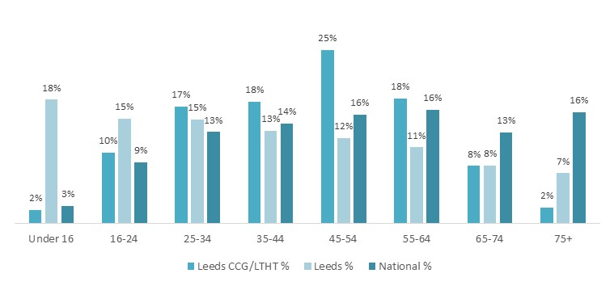

Table to display image above (Figure 6):

|  |  |  |  |
| --- | --- | --- | --- |
| Group | NHS Leeds CCG / LTHT % | Leeds % | National % |
| Under 16 | 2% | 18% | 3% |
| 16 – 24 | 10% | 15% | 9% |
| 25 – 34 | 17% | 15% | 13% |
| 35 – 44 | 18% | 13% | 14% |
| 45 – 54 | 25% | 12% | 16% |
| 55 – 64 | 18% | 11% | 16% |
| 65 - 74 | 8% | 8% | 13% |
| 75+ | 2% | 7% | 16% |

The average score for “experience of getting a vaccine*”* by age group ranges from 9.0 to 9.8 out of 10. The lowest scoring age group was “prefer not to say*”* with an average score of 9.0. Four age groups had an average experience score of 9.8. When asked to rate the experience of booking their vaccination, the under 16s age group had the highest average score of 9.8, whereas respondents who stated they were over 75 years old rated the system 7.7 on average. This is in line with expected technological capabilities of the demographic. Full detail can be seen in figure 7 below.

Figure 7. Average score by Age group

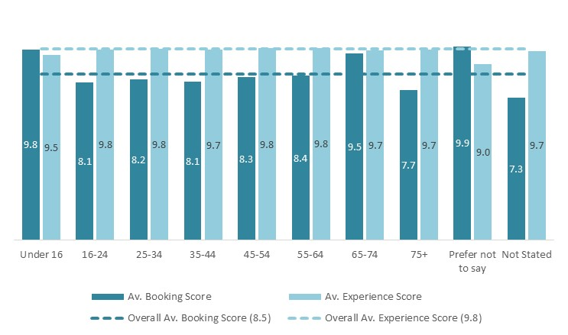

Table to display image above (Figure 7):

| Group | Average booking score (out of 10) | Average experience score (out of 10) |
| --- | --- | --- |
| Under 16 | 9.8 | 9.5 |
| 16 – 24 | 8.1 | 9.8 |
| 25 – 34 | 8.2 | 9.8 |
| 35 – 44 | 8.1 | 9.7 |
| 45 – 54 | 8.3 | 9.8 |
| 55 – 64 | 8.4 | 9.8 |
| 65 - 74 | 9.5 | 9.7 |
| 75+ | 7.7 | 9.7 |
| Prefer not to say | 9.9 | 9.0 |
| Not stated | 7.3 | 9.7 |

### Ethnicity

86% of respondents stated their ethnicity as White, while 7.7% (1,726) stated they are from a Black, Asian and minority ethnic (BAME) background. There were no noticeable differences between the respondent’s ethnicity and the average experience score. The lowest average for a respondent’s experience score, for those who shared their ethnicity, was seen in the Black, African, Caribbean or Black British group, however this still scored a high 9.5 out of 10 (vs 9.8).

However, when the 10-point satisfaction scales are transformed into two categories (‘lower’ scores of 1-5 and ‘higher’ scores of 6-10), the resulting statistical analysis shows that 2.9% of ‘White’ and ‘Other’ respondents scored in the ‘lower’ category compared to 4.6% of BAME respondents. This difference is statistically significant - although this is for booking a vaccine only - there was no difference in terms of receiving the vaccine in the lower score range. Further detail is shown in Figure 8. Figure 9 shows the proportion of respondents by ethnicity against the ethnicity proportion of Leeds while Figure 10 displays the respondents’ average experience and booking score by ethnicity.

Figure 8. Respondents Booking Score Distribution by Ethnicity

|  |  |  |  |
| --- | --- | --- | --- |
|  | BAME | White | Other |
| Score 1 – 5 (low) | 4.6% | 2.9% | 1.7% |
| Score 6 – 10 (high) | 95.4% | 97.1% | 98.3% |

Figure 9. Respondents by Ethnicity against Leeds Overall Population by Ethnicity

visual representation of respondents by ethnicity:

White ethnicity accounted for 86% of survey responses compared with 85.1% of the Leeds population

Other ethnic groups accounted for 0.8% of survey responses compared to 1.1% of Leeds' population

Mixed / multiple ethnic groups accounted for 1.4% of survey responses compared to 2.6% of Leeds' population

Black / African / Caribbean / Black British ethnicities accounted for 1.7% of survey responses compared to 3.4% of Leeds' population

Asian / Asian British ethnicities accounted for 4.5% of survey responses compared to 7.8% of Leeds' population

Not stated accounted for 4.7% of survey responses

Prefer not to say accounted for 0.9% of survey responses

Figure 10. Average score by Ethnicity

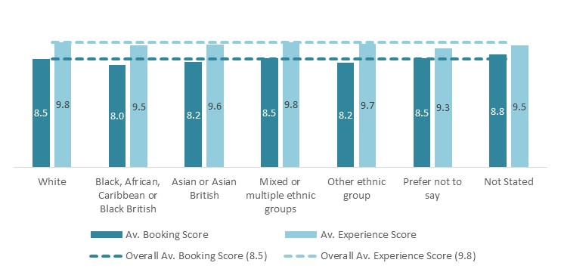

Table to display image above (Figure 7):

| Group | Average booking score (out of 10) | Average experience score (out of 10) |
| --- | --- | --- |
| White | 8.5 | 9.8 |
| Black, African, Caribbean or Black British | 8 | 9.5 |
| Asian or British Asian | 8.2 | 9.6 |
| Mixed or multiple ethnic groups | 8.5 | 9.8 |
| Other ethnic groups | 8.2 | 9.7 |
| Prefer not to say | 8.5 | 9.3 |
| Not stated | 8.8 | 9.5 |

### Disability

6.1% of survey participants stated that they had a disability, with the majority (87.6%) reporting that they do not consider themselves to have a disability. Those who said they did have a disability gave the lowest average ‘Experience score’ within this category; however, the average was still a high 9.5 out of 10. Figure 11 displays the split of how respondents answered the disability question, along with the average score for the group, and the disability breakdown for the Leeds area (obtained from the 2011 census).

“Having a disabled son, he was with the doctors who have dealt with him all his life that he hadn’t seen for a year (phone appointments). I don’t know who was more excited - him or our wonderful doctors! Felt amazing getting our jabs to help the NHS who were always outstanding but are now even more respected.”

Figure 11. Respondents by disability

visual representation of respondents by disability:

Of the people who answered the question on disability:

87.6% stated they did not have a disability and averaged a 9.8 score of satisfaction

6.1% stated they did have a disability and averaged a 9.5 score of satisfaction

5% did not indicate either way if they did had a disability or not and averaged a 9.6 score of satisfaction

1.4% stated they preferred not to answer the question and averaged a 9.6 score of satisfaction

In Leeds, 83.3% of the population do not have a condition that limits their day-to-day activities. 8.9% of Leeds state they have a condition that limits them a little and 7.9% have a condition that limits their activities a lot.

When the 10-point satisfaction scales are transformed into two categories, in terms of booking scores, 4.8% of the disabled group had ‘lower’ scores (1-5) compared to 3.0% for the non-disabled group - and this difference is statistically significant. In terms of receiving the vaccine, the percentage difference in ‘lower’ scores is 3.2% for the disabled group compared to 0.9% for the non-disabled group, and this difference is statistically significant at the < 0.05 significance level.

### Language

A total of 188 respondents (0.8%) said that English was not their first language. When looking at how these participants rated their experience of receiving their vaccine, it was in line with the overall average of 9.8 with a score of 9.7. Additionally, 53 (0.2%) respondents said that they used the interpreting services on offer for the vaccination process. The average experience score for these participants was 9.4, slightly lower than the overall average of 9.8. This small difference may be attributed to the large difference in sample size between the overall respondents (22,379) and those who said they used the interpreting services (53 out of the 188 respondents who identified English as their second language).

## Location

The two surveys attracted responses from people who were vaccinated across most regions of the Leeds metropolitan district. A large proportion of respondents (95.7%) said they had received their vaccine at a location with a Leeds postcode. Out of all the respondents, 64.3% said they attended Elland Road Vaccination Centre for their vaccine, the most popular vaccination centre. Figure 12 (below) shows the count of respondents by vaccination centre.

Figure 12. Respondents by Vaccination Centre

Map of respondents by vaccination centre highlighting the three most used locations based off of responses to the survey

1. Elland Road 
2. Thackray Museum
3. Alwoodley Medical Centre

*Elland Road Vaccination Centre*

*Thackray Museum Vaccination Centre*

*Alwoodley Medical Centre*

### Vaccination Centres

A total of 101 centres were identified by respondents, withThackray Museum Vaccination Centre being the second most popular venue according to respondents. 1,725 (7.7%) respondents said they attended this site for their COVID jab. Figure 13shows the three vaccination centres most frequently visited by respondents compared to the remaining 98 centres. There were 646 (2.9%) respondents who were not sure which centre they attended (47) or didn’t answer the question (599).

“The team are incredible at what they do and so, so lovely! On my first visit when I collapsed everyone was so accommodating and caring and made sure I was comfortable. A huge thank you to everyone… you’re all fab!”

Figure 13. Top three venues by % of respondents attending vaccination centres

*visual representation of top 3 vaccination venues as percentages compared to all other centres:

64.3% attended Elland Road vaccination centre
7.7% attended Thackray Museum
4.5% attended Alwoodley Medical Centre
23.6% attended all other centres*

### Location Experience Ratings

*“So impressively organised and staffed by the best team in the world. NHS workers were so friendly, warm and welcoming whilst being calm, caring, reassuring and above all else super professional. You’re all just amazing! True heroes.”*

To allow sufficient participant trend analysis, the following review only considers vaccination centres which have had survey results from 10 or more participants. There were 52 vaccination sites receiving responses from 10 or more people across both surveys. Survey participants were asked to rate their experience of receiving their vaccine on a scale of 1-10, 10 being the highest.

Of these locations, Trinity Centre (50 respondents), Abbey Grange Medical *Practice* (32*)* and York Street Health Practice(12*)* received the highest rating of 10 from all 94 respondents for their vaccination experience. The lowest rated site received an average of 7.3 from the 20 survey respondents. Figure 14 shows the top 10 sites for the experience score with the count of respondents for each site.

Figure 14. Respondent’s experience’ ratings by vaccination centre

visual representation of respondents experience’ ratings by top 10 vaccination centre:

Trinity Centre - 10 (50 responses)
Abbey Grange Medical Practice - 10 (32 responses)
York Street Health Practice - 10 (12 responses)
High Field Surgery - 9.9 (54 responses)
Aire Valley Surgery - 9.9 (17 responses)
Robin Lane Health and Wellbeing Centre - 9.9 (15 responses)
Garforth Medical Practice - 9.9 (14 responses)
Shaftesbury Medical Centre - 9.9 (68 responses)
The Garden Surgery - 9.8 (13 responses)
Yeadon Health Centre - 9.8 (528 responses)

## Vaccine Dose

### Dose Received

A total of 15,969 respondents (71.4%) reported which dose they had received. Of these, 10,474 (65.6%) said they had received their first dose and 5,495 (34.4%) said they had received their second dose. There was little difference between the ‘Experience averagescores’ depending on which dose the respondents received with both scoring an average of 9.7. However, there was a noticeable difference in people rating their experience of booking their vaccination when considering which dose they received. Respondents who said they had only received their first dose gave the booking experience an average rating of 8.1, which is a difference of 1.5 lower than the average rating of 9.6 for respondents who had received their second vaccine.

Furthermore, when the 10-point satisfaction scales are transformed into two categories, there is a greater degree of ‘lower’ scores (1-5) with the first dose (3.4%) compared to the second dose (2.2%) - and this difference is statistically significant. This would suggest that people were more confident using the booking system following their initial experience. Figure 15 shows the count of respondents by which dose they said they received.

Figure 15. Dose received by respondents

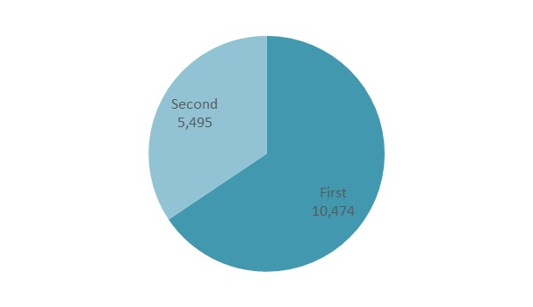

## Experience of Receiving the Vaccine

Participants were asked to rate their experience of receiving the vaccine and were able to leave comments to elaborate further on their overall views of the process. This provided insights into how patients felt after receiving their vaccine, as well as valuable feedback to help identify how the process could be improved.

### Comments by Sentiment

Overall, the majority (89.6%) of the respondents said that their experience was positive with 39.4% of comments identified as ‘very positive’. Comments such as “Staff were very polite and very helpful” and “Absolutely nothing could have been improved, in and out in 10 minutes, very fluid and extremely friendly and helpful staff and volunteers” were identified as ‘Very Positive’.

Only a small percentage (10.4%) of comments were categorised as ‘negative’. Figure 16 shows the proportion of comments by sentiment and Figure 17 is a visual ‘word-cloud’ representation of the most used words from the participants for this question (where the larger the font, the more frequent the response).



*“The man who did that vaccine was so patient and kind - I didn’t get upset because of needles or anything, just felt emotional that it was finally happening! I have never felt rushed here by staff. Thank you so much!”*

Figure 16. Comments on participants’ experience by sentiment

visual representation of comments on participants’ experience by sentiment:

39.4% of comments were very positive
50.2% of comments were moderately negative
6.2% of comments were moderately negative
4.3% of comments were very negative

Figure 17. Comments on participants’ experience by frequency

**Word cloud visual of participants comments around experience. Listed in order of most commonly used to least:

Organised
Efficient
Staff
Friendly
Well 
Helpful
Professional
Quick
Excellent
Everyone
Great
Easy
Experience**

### Examples of Respondents’ Sentiments

Below are just a few examples of some of the comments received from survey participants in response to their experience of receiving their vaccine.

**Positive**

**“**All the staff were amazing! I was treated with excellent kindness and understanding. Everything was explained to me in detail and all questions answered. They were courteous to all the people there.”

“The supervisor who saw me was incredible, I have an intense needle phobia and she was patient and allowed my father to come in with me. She explained the process and didn’t fluff it up which is what I needed. She explained when the needle would go in and helped me prepare and also sat with me while I calmed down from a panic attack. She couldn’t have done anything better. “

“After receiving my booster jab, I came over feeling slightly unwell. The staff we're all amazing and straight away put me at ease, made sure I was taken care of, and given water. I would like to thank them all. Amazing care!”

**Neutral**

“My appointment was 2.10pm. I had to wait for an hour and twenty-five minutes after this to actually get my vaccination. The staff were all really helpful and lovely, but the wait was extremely unpleasant, I was cold and had a very sore back by the time I went into the building. “

“We had a half an hour wait at the station before getting the vaccine and people arriving after us kept getting seen before us which was pretty frustrating! But everyone was very pleasant”

**Negative**

“Very unorganised. I booked for 1:50pm and arrived at 1:40pm to a queue of people. There were people ahead of me in the queue who were booked for 2:10 so it was basically a free for all. No one checked any times. Attendants to the queues were rude and making jokes about us all queuing up. I finally got seen at 3:30  
And was able to leave at 3:45. No apologies or compassion anywhere and 2 hours of work I have missed that I now have to catch up. Just one concerned, compassionate member of staff would have made that a whole better experience”

### Customer Experience - Rating Over Time

From the survey responses, the earliest people said they received their vaccination was December 2020, with the latest being February 2022. Over this time, the average experience rating for participants, based on the month they stated they received their vaccine, fluctuated between 9.2 (Jan-22) to 9.9 (Mar-21, Aug-21 and Sep-21). The lowest scoring month for respondents’ experience (Jan-22) coincided with the highest monthly new COVID cases recorded for the UK. This could suggest a direct link between patient satisfaction and COVID surges. This theory is further supported when looking at the other end of the scale. The joint-highest scoring month for respondents’ experience (Mar-21) is also one of the lowest months for new COVID cases in the UK during this time. March 2021 was also the highest month for participants to receive their vaccine with 27.4% of respondents, who informed of their vaccine date, saying they were vaccinated in Mar-21. Figure 18 shows the month-on-month fluctuation over this time against the new recorded COVID cases, within the UK, by month.

When considering the day that respondents said they attended a vaccination centre, the most popular was Saturday with 3,704(17.4%). The least popular day for respondents to book their appointment was a Monday, with 2,578 (12.1%) selecting this day. The day of a vaccine had little impact on the respondents’ experience rating with Tuesday (9.72) having the lowest rating and Sunday (9.83) receiving the highest.

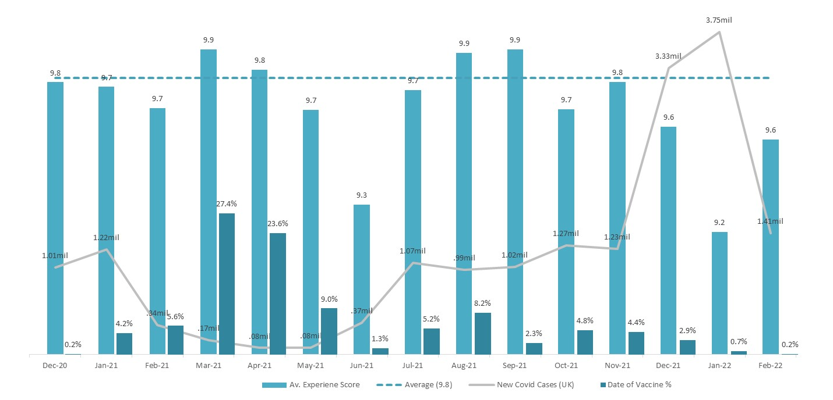*Figure 18. Respondents’ Average Experience Rating by Month*

Table to display image above (Figure 18):

| Group | % of respondents who got their vaccine | Average experience score (out of 10) | New COVID cases in the UK |
| --- | --- | --- | --- |
| December 2020 | 0.2% | 9.8 | 1.01 million |
| January 2021 | 4.2% | 9.7 | 1.22 million |
| February 2021 | 5.6% | 9.7 | 0.34 million |
| March 2021 | 27.4% | 9.9 | 0.17 million |
| April 2021 | 23.6% | 9.8 | 0.08 million |
| May 2021 | 9% | 9.7 | 0.08 million |
| June 2021 | 1.3% | 9.3 | 0.37 million |
| July 2021 | 5.2% | 9.7 | 1.07 million |
| August 2021 | 8.2% | 9.9 | 0.99 million |
| September 2021 | 2.3% | 9.9 | 1.02 million |
| October 2021 | 4.8% | 9.7 | 1.27 million |
| November 2021 | 4.4% | 9.8 | 1.23 million |
| December 2021 | 2.9% | 9.6 | 3.33 million |
| January 2022 | 0.7% | 9.2 | 3.75 million |
| February 2022 | 0.2% | 9.6 | 1.41 million |

### Customer Feedback – *What could have been better?*

Respondents were asked if there was anything that could have been done better, and 2,238 responses were received. Auto coding using NVivo software identified several themes related to potential improvements – see Table 1 below.

Table 1. NVivo Auto coded Potential Improvements Themes

|  |  |  |
| --- | --- | --- |
| Auto coded Themes | % | Examples |
| Appointment | 10.5% | Weekend appointment, different appointment, early appointment, better system |
| Time | 9.7% | Time slots, allotted time, waiting time, exact times, later time slots, different time slots, staggered time slots, actual time, little time, correct time, both vaccines booked at same time |
| Booking | 7.8% | Booking details, awkward booking, current booking, phone booking, booking site, difficult booking |
| Waiting | 6.4% | Waiting room, waiting list, waiting area |
| Park | 6.3% | Enough parking, cold car park, finding parking, on-street parking, parking situation |
| Queue | 6.0% | Huge queue, unfair queuing, big queue, cold weather – outdoor queue |
| Centre | 5.4% | Health centre, mass centres, different centres, large centres, medical centre, more signs |
| Text | 4.4% | Text message, reminder text, text invitation, confirmation text |
| Phone | 3.9% | Phone booking, personal phone, phone lines |
| Area | 3.8% | Waiting area, recovery area, seating areas |
| Social Distancing | 3.8% | No social distancing, very little social distancing, more on top of social distancing |
| Room | 3.7% | Waiting room, indoor room, crowded consultation room, private room, more chairs |
| Staff | 3.3% | Friendly staff, staff sweeping back and forth, good staff |
| Process | 3.0% | Speedy process, clinical process, brilliant process, smooth process |
| Experience | 2.8% | Good experiences, brilliant experience, stress experience, straightforward experience, experienced travel problems |
| Card | 2.8% | Small card, record card, official cards |

Many respondents stated that *‘*nothing could have been done better’and reiterated positive feedback about the process and the friendliness of staff.

A key theme related to more flexible appointments – more availability at the weekend or earlier in the day. A second theme related to time and the variability experienced in terms of booked appointment time to actual time they received the vaccine. Some respondents also suggested that the appointments for first and second doses could have been booked at the same time. The queues were difficult for some, and many suggested a need for seated waiting areas, allowing for social distancing. The provision of a formal vaccination card was requested by some respondents.

Importantly, these themes may explain why disabled people were more dissatisfied - reiterated in the some of the comments suggesting what could be improved:

‘Sort things so people didn’t need to queue outside in cold standing up. Bad for disabled who have difficulty standing’.

‘Possibly need to think about disabled and older people queuing outside in winter’

A visual scan of the comments showed a key theme not picked up in the NVivo analysis relating to the theme of language barriers and the need for improved translation and diversity. This may explain the differences in the lower scores outlined in the previous section:

‘Language barrier, would like to see nurses from diverse communities’

‘Would have liked to see more Asians to help me’

‘Having diverse nurses and doctors at the centre’

‘NHS needs to improve on their communication (Language Barriers)’

‘Lack of communication need translator, language barrier’

In terms of specific information that could have been provided:

‘More information of allergies’

‘Maybe state about clothing’ (to expose arm)

‘Not given enough time to read the brochure’

‘good if the booking system signposted you to the information leaflet link. If it already does this then perhaps I missed the link’.

*h*

## Revised Vaccination Decision

Survey participants were asked if they had always planned on getting a vaccine, and if not, what had changed their minds. In total, 11,667respondents answered this question. Of these 95.8% (11,173) replied yes, they were always intending on getting a COVID vaccination, and only 4.2% (494) said no.

### Reasons for Changing Decision

From the respondents who stated they weren’t always planning on having a COVID vaccine, the main reason they changed their minds was due to ‘COVID restrictions’. 20.2% (100) of respondents who answered this question stated that the social restrictions in place were the reason they had the vaccine. Other common themes from the comments from respondents who changed their minds on receiving the vaccine were; friends and family influence (14.2%), to reduce the spread of COVID (9.3%), work related needs (6.9%) and initially waiting before deciding to be vaccinated (5.1%). Figure 19 shows the top 10 reasons, grouped by themes, based on respondents’ comments on why respondents changed their mind on getting vaccinated.

visual representation of why respondents changed their mind on getting vaccinated, the top 10 reasons mentioned were:

1. COVID restrictions
2. Friends and family
3. Reduce the spread
4. Work
5. Initially waited
6. Research
7. Media
8. Maternity
9. Side effects
10. Doctors influenceFigure 19. Why respondents changed their mind on getting vaccinated

### Key Themes Arising Regarding Vaccine Decision

**COVID Restrictions** – The vast majority of respondents who changed their minds on receiving the vaccination due to COVID restrictions stated that they wanted to go abroad. 78 out of the 100 within this group mentioned “holiday”, “abroad”and / or *“*travel” within their comments. It appears that people who didn’t want to get the vaccine felt pressured into doing so, in order to be able to undertake activities that they normally have been involved in prior to the pandemic. Below are examples of respondents’ comments on this theme.

|  |
| --- |
| “I want to go on holidays and do things that are needed with the vaccine”  “Just unsure if I needed to get it, but I like to travel”  “Not being able to go to football or on holidays, so basically same as half the population I have been forced into having the jab”  “Restrictions to holidays etc, I’m not anti-vaccine just would prefer to let me body’s immune system to work on its own”  “You may not be able to travel abroad without proof that you have had the vaccine.” |

**Friends & Family –** Two main themes emerged from the group of respondents whose comments on why they changed their minds related to friends and family. Some participants said that they wanted to visit and / or protect their friends and family and felt it was best to be vaccinated, whilst other respondents stated that they were pressured into getting their vaccine by friends and family. Below are some comments which highlight the two different viewpoints of the respondents in this category.

|  |
| --- |
| “I just wanted to protect family and friends”  “I care for my elderly parents, and I wanted to protect them as much as possible”  “Pressure from friends and family”  “My mum pleaded me to have it.”  “I was later convinced it was safe thanks to numerous friends having done it”  “Pestering from parents and partner" |

**Reduce the Spread –** From the 46 people whose comments related to reducing the spread of the virus, the common theme emerging was that people wanted to protect others. Some respondents remarked on the fact that cases were rising, and they wanted to help reduce the number of COVID infections, below are some examples of these comments.

|  |
| --- |
| “I felt it was my duty to help contain the virus.”  “The second strain, how fast it was spreading and was impacting a lot younger people”  “Protect others as I will have to have more contact with other people”  “I caught covid and realised how horrible the feeling was. Didn’t wanna go through it again.  Also wanted to make sure I protected my family and vulnerable people around me.” |

Some other notable themes include

* People having to be vaccinated to comply with their workplace regulations.
* Respondents wanted to wait initially to ensure the vaccines were sufficiently tested.
* Respondents wanted to ensure any side effects weren’t too severe before deciding to be vaccinated themselves.

### Revised Vaccination Decision Demographics.

**Gender** – When considering gender there was a slight difference between female and male respondents who indicated that they were originally reluctant to be vaccinated, compared to the overall proportion of survey participants. Figure 20 shows the proportion of respondents’ initial view on receiving the vaccine, by gender, whilst Figure 21 displays the difference between the respondents who were initially reluctant to be vaccinated against the overall proportion of survey participants.

Figure 20. Breakdown by gender on whether respondents were always intending to be vaccinated

|  |  |  |  |
| --- | --- | --- | --- |
|  | Female | Male | Other |
| Yes | 95.4% | 96.6% | 96.1% |
| No | 4.6% | 3.4% | 3.9% |

Figure 21. Respondents who changed their mind on getting vaccinated by gender

*visual representation of respondents who changed their mind by gender who were initially reluctant:

59% of females who were initially reluctant changed their mind

33% of males who were initially reluctant changed their mind

1% of people who are non-binary who were initially reluctant changed their mind

6% of people who did not state a gender who were initially reluctant changed their mind

2% of people who chose 'prefer not to say' who were initially reluctant changed their mind*

**Disability** – There was a notable difference between the overall proportion of respondents with a disability (6.1%) and the proportion of participants who changed their mind on receiving a vaccine and having a disability (8.3%). This could be attributed to respondents initially being concerned that they were vulnerable and that the vaccine might cause additional health issues. Some of the participants’ comments do support this assumption. Below are examples of respondents’ comments around why they changed their mind regarding vaccination.

|  |
| --- |
| “I think as I am shielding due to being CEV (clinically extremely vulnerable) I was very reluctant to get the vaccine and felt it had come round quite quickly. However, the more research that came out about it and its effectiveness I felt it was the only way to get a grip on the virus and the only way out of this pandemic. I felt I had nothing to lose but hopefully something to gain by having the vaccine.”  “Initially no, due to health anxiety - fear of vaccine side effects / how I might feel after them were initially higher than my fear of catching COVID as I was at home so much. But as I started going out in public more after the lockdowns, I started to feel more and more uneasy and fearful and so fears of side effects were overridden by a want to live my life without feeling so anxious about COVID. I’m now so glad that I made the decision to have it, and I had barely any side effects with my first dose!” |

That said, only 4.6% of the disabled respondents’ population said that they had not originally planned to be vaccinated. This is slightly higher than the 4.2% of the full group of respondents. This is displayed in Figure 22.

**Ethnicity** – When comparing Black, Asian and minority ethnic (BAME) respondents who were initially opposed to getting a COVID vaccine (23.9%) against the overall proportion of survey participants who are from a BAME background (7.7%) there is a notable difference of 16.2%. Around June 2020, there was a considerable amount of media traffic highlighting the high rates of death and serious illness among BAME communities after data published by the government (<https://www.gov.uk/government/publications/covid-19-understanding-the-impact-on-bame-communities>).

It was also noticed that vaccine hesitancy was higher within the BAME communities with a lower uptake of vaccination. This led to a government campaign that included social media videos, celebrity adverts and community champions to encourage take up (<https://www.ovg.ox.ac.uk/news/covid-19-how-to-tackle-vaccine-hesitancy-among-bame-groups>).

Although there are no comments specifically referring to this from respondents, there were a number of BAME participants who said they changed their mind following influence through a charitable organisation (8) such as Baha and Circles of Life Voice for Men, their own research (7) and what they had seen in the media (3). The reasons why respondents from minority ethnic backgrounds changed their mind, and decided to be vaccinated, are largely similar to that of all respondents who were initially hesitant. COVID restrictions, friends and family influence and work-related reasons were the most common amongst participants from a BAME background.

A total of 10.8% of the BAME respondents said they were initially not intending to be vaccinated. This is above the general population of respondents (4.4%) who were not originally planning to receive the vaccine. See Figure 18 for comparison.

Figure 22. respondents who changed their mind – Disabled and BAME respondents

visual representation of respondents who changed their mind overall, by disability and by ethnicity:

Overall: 95.8% were not hesistant, 4.2% were

Disabled respondents: 95.4% were not hesitant, 4.6% were

BAME respondents: 89.2% were not hesitant, 10.8% were

## Responding to Patient Feedback

NHS Leeds CCG and LTHT continuously monitored patients’ feedback following their vaccination. From this feedback they were able to implement changes to the vaccination process that would improve their patients’ experiences of getting vaccinated in one of the sites. Below are some of the examples of changes implemented off the back of patient feedback.

|  |  |
| --- | --- |
| **You Said** | **We Did** |
| Very well organised and helpful staff. Could put an obvious clock in area when waiting after jab as not everyone has a phone with them. | There are now clocks located in the recovery area of the centre and we have ordered more of these to place on walls so they can be seen at a distance whilst sat waiting. |
| Only problem was hearing people, I am hearing impaired and lip read. Healthcare settings need to have some people with clear masks. | We have a supply of clear facemasks so that citizens requiring lip reading can see through to enable this. There are often sign language interpreters on site if they are not available, we have ‘Interpreters on Wheels’ that can also be used for this purpose. |
| My appointment was at 13:30, however, I didn’t get my vaccination until 14:30. I had to queue for almost an hour. There were two queues – one for first vaccination and one for second vaccination. This was not clear at all. | One queue lane now feeds one pod, therefore shortening the overall length of the queue. We have introduced a member of staff at the entrance to triage, explaining which vaccine and answering questions ahead of pod. We have set up an ‘assessment booth’ for anyone who requires additional support (needle phobic, further discussion with medic etc.). Citizens are escorted to the booth so time can be spent there, therefore maintaining the low in the pods. |

# Key takeaways

The following key takeaways arising from this research are drawn from the dominant views and characteristics of respondents. They focus on summarising the important respondent demographics; location of vaccination centre; satisfaction with experience; changing views on the vaccination and influences on this decision making. The final key takeaway focuses on ‘things to consider’ in terms of translating the response analysis into recommendations for improving the surveys’ reach and coverage and the overall process.

1. **Satisfaction with experience**

* In general, people were very positive about their vaccination experience.
* There was no statistically significant difference in satisfaction ratings based on the vaccine dose received (getting the vaccine).
* In terms of booking for the vaccination, people were more satisfied with their experience for the second dose than the first.
* Although there was some fluctuation in satisfaction depending on the time / month the vaccination was received, the levels were all very positive.

1. **Characteristics of respondents and differences in satisfaction rates**

* Satisfaction scores across all groups were generally high, with 9.8 out of 10 being the overall average.
* 54.1% of respondents were female, and females were more likely to score in the ‘lower’ 1 - 5 range (on a 10 point scale) in terms of booking the vaccine.
* 7.7% of the sample were from a BAME background and although the overall average scores were very good across all groups, those from a BAME background were more likely to score in the ‘lower’ 1-5 range.
* The most represented age group was 45 - 55 years. The 65 - 74 age group were more likely to be dissatisfied.
* There was very little take-up in the survey in the under 16s category
* Just over 6% of respondents had a disability. Those that were disabled were more likely to score in the ‘lower’ 1-5 range than those that were not disabled, for both booking the vaccine and getting the vaccine.

1. **Location**

* There was a wide selection of potential venues for respondents to choose from with 101 vaccination sites identified by respondents.
* Respondents predominantly selected Elland Road as their choice of venue for their vaccination.
* Only 50% of all venues were represented by 10 or more responses to the survey.

1. **Changing views**

* The vast majority of respondents always intended to get vaccinated.
* Of those that originally had not intended to get vaccinated, the main influence in terms of their ‘change of mind’ was around the restrictions tied to not being vaccinated.
* ‘Family and friends’ were also a major influencer – either pressure from them for individuals to get vaccinated, or concern from individuals about protecting others
* Notable differences could be seen regarding a change of opinion on being vaccinated in those people with a disability and people from a BAME community.

1. **Things to consider**

* Ensuring that there are adequate facilities for disabled people, for example, adequate seating.
* Ensuring adequate translation services to meet the needs of diverse communities and improve representation.
* There needs to be consistency in surveys in terms of questions asked and the structure of those questions.
* There may be some element of bias / skewing of results due to Elland Road being the predominant venue for vaccinations.
* Any differences in demographics compared to Leeds City need to be addressed.
* It would be informative to follow up the surveys with some qualitative research such as focus groups / interviews.
* It would be good to compare these findings with any available results from other regions.
* There should be a consideration of the ‘so what’ in terms of what will happen next – will there be a response to some of the negative feedback? Will the results inform future practice? Will good practice be communicated?

# Annexes

# 

# Example of Respondent Quotes



“From beginning to end everything has been great, but the cherry on the cake was the nurse giving the vaccine - so calm and professional - amazing... if everyone's had that experience... Wow!”

“Very glad to have come and got the jab - feel relieved.”

“I know what it can be like - was in hospital with my friend when he got it. Not nice. I know what it can be like. He died.”

“Really fast, staff and volunteers were so friendly and polite. Can’t wait to attend for my second one.”

“Having had Covid-19 last year, I was excited to receive the vaccine knowing I am protected from a horrible disease.”

“I was incredibly anxious due to having needle phobia. I explained this to the nurse and that I was having CBT around this. Two nurses supported me, and they were extremely kind and compassionate and made the whole experience as positive as it could possibly be for me. Be proud - you are amazing!!”

“Having a disabled son, he was with the doctors who have dealt with him all his life that he hadn’t seen for a year (phone appointments). I don’t know who was more excited - him or our wonderful doctors! Felt amazing getting our jabs to help the NHS who were always outstanding but are now even more respected.”

“I felt so privileged and relieved as I’ve been shielding my husband with advanced cancer since last March.”

“Even more respect for the teams rolling out the vaccines, truly inspiring people.”

“Can’t wait for the second dose. Bring it on!”

“Exceptionally efficient - everyone was friendly - painless - thank you to everyone.”

“I am in awe of the NHS. It was extremely efficient and friendly from start to finish. My husband & I shared the same appointment which was fantastic. Thank you!”

“Makes me proud to be British. It was brilliantly done.”

“So quick and well-staffed, like a Formula 1 pit stop!”

“Made my year! An emotional experience and the first step towards normality.”

“Thank you for managing such an incredible project.”

“Smooth, calm, humbling.”

“The sheer speed and efficiency with the vaccination. Nice welcome at the door. Jokes while waiting. Friendly doctor. Well organised rest room. Felt everything was clean and safe. Very well done!”

“The team are incredible at what they do and so, so lovely! On my first visit when I collapsed everyone was so accommodating and caring and made sure I was comfortable. A huge thank you to everyone… you’re all fab!”

“The man who did that vaccine was so patient and kind - I didn’t get upset because of needles or anything, just felt emotional that it was finally happening! I have never felt rushed here by staff. Thank you so much!”

“Everyone was so kind and helpful as I am hard of hearing and have mobility problems. Everything was so well run and as I was feeling vulnerable without my husband being with me it was helpful to have so many people directing you where to go. Thank you so much.”

“So impressively organised and staffed by the best team in the world. NHS workers were so friendly, warm and welcoming whilst being calm, caring, reassuring and above all else super professional. You’re all just amazing! True heroes.”



This section contains a lot of resource that covers the stats mentioned in the report in one place, including copies of the surveys used. These are not in an accessible format as they are currently in this document.

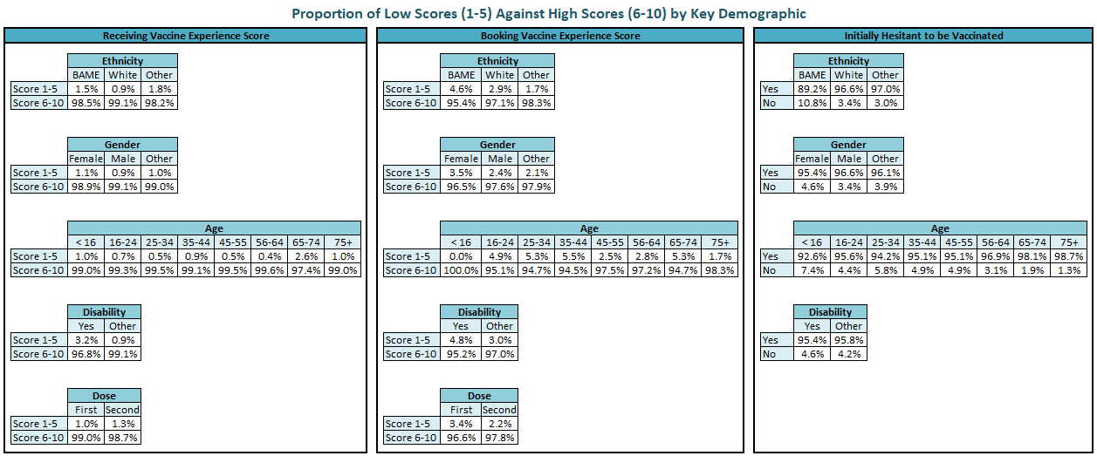

# Survey Copies

**LTHT Version**

We would like you to think about your experience of our COVID Vaccination Centre. By answering the questions it will help us to understand your overall experience. This will help us to measure and improve the quality of care we give at our Vaccination Centres

Please select the location of your vaccination:

Vaccination Centre Schools

Please select the date of your visit

Thinking about your visit to our Vaccination Centre, overall how was your experience of our service?

Very good Good Neither good nor poor Poor Very poor Don’t Know

Please can you tell us why you gave your answer and what we could have done better?

Which vaccination centre did you visit?

In relation to the environment, social distancing and hand sanitising did you feel safe during your visit?

Yes No

Was there a member of staff that went the extra mile?

Yes No

Do you recall their name? What did they do that was special?

Is English your first language?

Yes No

Did you use our interpreting services for this vaccination process?

Yes No

What is your gender?

Male Female Transgender Other Prefer not to say

What age are you?

What is your ethnic group?

Mixed / multiple Black / African /

White ethnic groups Other ethnic group Caribbean / Black Asian / Asian British

Other ethnic group Prefer not to say

Do you have a disability?

Yes, limited a lot Yes, limited a little No Prefer not to say

We would like to be able to share your anonymous comments from your FFT with other health care partners and organisations to aid with future research and quality improvement exercises. Would you be happy for your comments to be used in this way?

No Yes

**NHS Leeds CCG Version**

We want to hear from people about their experience of receiving their COVID-19 vaccination.

We will use your comments to feedback to our vaccination teams, to inform others about what to expect when going for their vaccination, and to help improve the vaccination experience for everyone in Leeds wherever we can.

The survey is short so shouldn't take too long. We really appreciate you taking the time to give us your feedback.

Where did you get your vaccine?

Which dose did you receive?

First Second

On a scale of 1-10 (with 1 being terrible and 10 being excellent), how would you rate your experience of booking your vaccine appointment?

1 2 3 4 5 6 7 8 9 10

What one word would you use to describe your experience of booking your vaccination?

On a scale of 1-10 (with 1 being terrible and 10 being excellent), how would you rate your experience of getting your vaccine?

1 2 3 4 5 6 7 8 9 10

What one word would you use to describe your experience of getting your vaccination?

Is there anything that could have been done better?

Do you have any other comments about your experience on getting your vaccination?

Equality Monitoring

Please tick here if you would prefer not to answer any of the equality monitoring questions

I would prefer not to answer any of the equality monitoring questions

What is your postcode?

What is your age?

Are you disabled? (The Equality Act 2010 defines disability as ‘a physical, sensory or mental impairment which has, or had a substantial and long-term adverse effect on a person’s ability to carry out normal day to day activities’.)

Yes No Prefer not to answer

If yes, what type of disability? (tick all that apply)

Long-standing illness Physical impairment Learning disability Mental health condition

Hearing impairment Visual impairment Prefer not to answer Other

What is your ethnic background?

|  |  |
| --- | --- |
|  | Prefer not to say |

White

|  |  |
| --- | --- |
|  | British (English/Welsh/Scottish/Northern Irish) |
|  | Irish |
|  | Gypsy or Traveller |
|  | European |
|  | Any other white background (please state)   |  | | --- | |  | |

 Mixed or multiple ethnic groups

|  |  |
| --- | --- |
|  | White and Black Caribbean |
|  | White and Black African |
|  | White and Asian |
|  | Any other Mixed or Multiple ethnic (please state)   |  | | --- | |  | |

 Asian or Asian British

|  |  |
| --- | --- |
|  | Indian |
|  | Pakistani |
|  | Bangladeshi |
|  | Chinese |
|  | Any other Asian background (please state)   |  | | --- | |  | |

 Black, African, Caribbean or Black British

|  |  |
| --- | --- |
|  | African |
|  | Caribbean |
|  | Any other Black, African or Caribbean background (please state)   |  | | --- | |  | |

 Other ethnic group

|  |  |
| --- | --- |
|  | Arab |
|  | Any other ethnic group (please state)   |  | | --- | |  | |

Pregnancy and maternity (The Equality Act 2010 protects women who are pregnant or have given birth within a 26 week period)

|  | Yes | No | Prefer not to say |
| --- | --- | --- | --- |
| Are you pregnant at this time? |  |  |  |
| Have you recently given birth (within a 26 week period)? |  |  |  |
| Are you a parent or carer of a child or children under the age of five years old? |  |  |  |

What is your religion or belief?

|  |  |
| --- | --- |
|  | Buddhism |
|  | Christianity |
|  | Hinduism |
|  | Islam |
|  | Judaism |
|  | Sikhism |
|  | No religion |
|  | Prefer not to say |
|  | Other (please specify):   |  | | --- | |  | |

Carers (A carer is someone who provides unpaid support/care for a family member, friend, etc. who needs help with their day to day life; because they are disabled, have a long-term illness or they are elderly.)

|  | Yes | No | Prefer not to say |
| --- | --- | --- | --- |
| Are you a carer? |  |  |  |
| Do you have unpaid responsibilities for children as a parent/grandparent/guardian? |  |  |  |

What gender best describes you?

|  |
| --- |
| Woman (including trans women) |
| Man (including trans man) |
| Non-binary |
| Prefer not to say |
| Other (please specify):   |  | | --- | |  | |

Are you transgender?(Is your gender identity different to the gender you were given at birth?)

|  |  |
| --- | --- |
|  | Yes |
|  | No |
|  | Prefer not to say |

Find out more

Please share your contact details below if you would like to receive updates about how you can have your say on health and care services in Leeds. If you give us your information we will be in contact with you soon.

Your personal information will be kept separate from the answers and your response to the questions will be anonymous.

What are your contact details?

Please note that you do not have to fill in your personal details to complete this survey.

|  |  |  |
| --- | --- | --- |
| Name | |  | | --- | |  | |
| Address and postcode | |  | | --- | |  | |
| Email | |  | | --- | |  | |
| Telephone | |  | | --- | |  | |
| GP practice | |  | | --- | |  | |

We may want to use what you tell us in a quote in any upcoming reports or social media posts. This is help promote the vaccine programme and demonstrate how we respond to feedback. If you are happy for your first name, area, and a quote to be used, please tick the box below.

For example:

“My experience getting a vaccination was great, it was well organised, and I was in and out in no time” Adam, Wetherby

|  |  |
| --- | --- |
|  | I'm happy for you to use a quote from my feedback in future social media or publications (please make sure you've given us some of your personal details above) |

If you would like to find out more about any future changes to your local health services, please tick this box to join our community network

|  |  |
| --- | --- |
|  | I would like to find out more about future changes to my local health services |

Acknowledgements go to the following individuals for their work on the patient feedback surveys and shaping the final report:

**Amanda Hynes**

Friends and Family Test Manager, Leeds Teaching Hospitals NHS Trust

**Caroline Mackay**

Community Relations and Involvement Manager, Leeds Office of the NHS West Yorkshire Integrated Care Board

**Adam Stewart**

Senior Insight, Involvement and Engagement Advisor, Leeds Office of the NHS West Yorkshire Integrated Care Board

**Will Ridge**

Senior Evaluation Manager, Leeds Office of Data Analytics